**St. Thomas’ College of Engineering and Technology**

**“Cyclone Casualty and Property Loss Prediction”**

**Prepared by**

|  |  |
| --- | --- |
| **Name** | **University Registration No** |
| **Satarupa Das** | **201220100210029 of 2020-21** |
| **Srijit Sarkhel** | **201220100210001 of 2020-21** |
| **Pratiksha Naskar** | **201220100210008 of 2020-21** |
| **Sayan Das** | **201220100210053 of 2020-21** |

**Under the guidance of**

**Amit Dutta**

**Assistant Professor, Department of Information Technology**

**PROJECT REPORT**

**Submitted in partial fulfillment of the requirement of the degree of B.Tech in Information Technology**

**Affiliated to**

**Maulana Abul Kalam Azad University of Technology, West Bengal**

**MAY, 2024**

**CERTIFICATION**

**ST. THOMAS’ COLLEGE OF ENGINEERING AND TECHNOLOGY**

**Faculty of Information Technology**

This is to certify that the work in preparing the project entitled “AI Personal Guide” has been carried out by Satarupa Das, Srijit Sarkhel, Sayan Das and Pratiksha Naskar under my guidance during the session of 2023-2024 and accepted in partial fulfillment of the requirement for the degree of B.Tech in Information Technology.

STCET-IT

Signature Signature

**Dr. Ranjit Ghoshal Mr. Amit Dutta**

Head, Department of Mentor, Department of

Information Technology Information Technology

**ACKNOWLEDGEMENT**

We hereby take this opportunity to thank our mentor, Mr. Amit Dutta for his kind guidance and constant motivation, without which this project would not have been possible.

We would also like to thank Dr. Ranjit Ghoshal, Head, Department of Information Technology for his encouragement, valuable advice, and feedback.

We also extend our gratitude towards the review committee for their valuable advice during the project review classes.

---------------------------------- ----------------------------------

Satarupa Das Srijit Sarkhel

---------------------------------- ----------------------------------

Pratiksha Naskar Sayan Das

**Vision & Mission**

**(St. Thomas’ College of Engineering & Technology)**

**Vision**

To evolve itself into an industry-oriented research based recognized hub of creative solutions in various fields of engineering by establishing progressive teaching-learning process with an ultimate objective of meeting technological challenges faced by the nation and the society.

**Mission**

* To create opportunities for students and faculty members in acquiring professional knowledge and developing social attitudes with ethical and moral values.
* To enhance the quality of engineering education through accessible, comprehensive, industry and research-oriented teaching-learning process.
* To satisfy the ever-changing needs of the nation for evolution and absorption of sustainable and environment friendly technologies.

**Vision & Mission**

**(Department of Information Technology)**

**__________________________________________________________**

**Vision**

To promote the advancement of learning in Information Technology through research oriented dissemination of knowledge which will lead to innovative applications of information in Industry and Society.

**Mission**

* To incubate students grow into industry ready professionals, proficient research scholars and enterprising entrepreneurs.
* To create a learner- centric environment that motivates the students in adopting emerging technologies of the rapidly changing information society.
* To promote social, environmental, and technological responsiveness among the members of the faculty and students.

**Program Educational Objectives (PEO)** _________________________________________________________________

Graduates of Information Technology Program shall:

**PEO1:** Exhibit the skills and knowledge required to design, develop and implement IT solutions for real life problems.

**PEO2:** Excel in professional career, higher education, and research.

**PEO3**: Demonstrate professionalism, entrepreneurship, ethical behavior, communication skills and collaborative team work to adapt to the emerging trends by engaging in lifelong learning.

**Program Outcomes (POs)**

**Engineering Graduates will be able to:**

1. **Engineering knowledge**: Apply the knowledge of mathematics, science, engineering fundamentals, and an engineering specialization to the solution of complex engineering problems.
2. **Problem analysis**: Identify, formulate, review research literature, and analyze complex engineering problems reaching substantiated conclusions using first principles of mathematics, natural sciences, and engineering sciences.
3. **Design/development of solutions**: Design solutions for complex engineering problems and design system components or processes that meet the specified needs with appropriate consideration for the public health and safety, and the cultural, societal, and environmental considerations.
4. **Conduct investigations of complex problems**: Use research-based knowledge and research methods including design of experiments, analysis and interpretation of data, and synthesis of the information to provide valid conclusions.
5. **Modern tool usage**: Create, select, and apply appropriate techniques, resources, and modern engineering and IT tools including prediction and modeling to complex engineering activities with an understanding of the limitations.
6. **The engineer and society**: Apply reasoning informed by contextual knowledge to assess societal, health, safety, legal and cultural issues and the consequent responsibilities relevant to professional engineering practice.
7. **Environment and sustainability**: Understand the impact of professional engineering solutions in societal and environmental contexts, and demonstrate the knowledge of, and need for sustainable development.
8. **Ethics**: Apply ethical principles and commit to professional ethics and responsibilities and norms of engineering practice.
9. **Individual and teamwork**: Function effectively as an individual, and as a member or leader in diverse teams, and in multidisciplinary settings.
10. **Communication**: Communicate effectively on complex engineering activities with the engineering community and with society at large, such as, being able to comprehend and write effective reports and design documentation, make effective presentations, and give and receive clear instructions.
11. **Project management and finance**: Demonstrate knowledge and understanding of the engineering and management principles and apply these to one’s own work, as a member and leader in a team, to manage projects and in multidisciplinary environments.
12. **Life-long learning**: Recognize the need for and have the preparation and ability to engage in independent and life-long learning in the broadest context of technological change.

**Project Mapping with Program Outcomes**

|  |  |  |  |  |  |  |  |  |  |  |  |
| --- | --- | --- | --- | --- | --- | --- | --- | --- | --- | --- | --- |
| **PO1** | **PO2** | **PO3** | **PO4** | **PO5** | **PO6** | **PO7** | **PO8** | **PO9** | **PO10** | **PO11** | **PO12** |
| **3** | **3** | **3** | **3** | **2** | **3** | **1** | **2** | **3** | **2** | **2** | **3** |

**1: Slight (Low) 2: Moderate (Medium) 3: Substantial (High)**

**Justification:**

**1. Engineering Knowledge:** Apply the knowledge of mathematics, science, engineering fundamentals, and an engineering specialization to the solution of complex engineering problems.

**2. Problem Analysis:** Identify, formulate, review research literature, and analyze complex engineering problems reaching substantiated conclusions using first principles of mathematics, natural sciences, and engineering sciences.

**3. Design/ Development of solutions:** Design solutions for complex engineering problems and design system components or processes that meet the specified needs with appropriate consideration for the public health and safety, and the cultural, societal, and environmental considerations.

**4. Conduct Investigations of complex problem:** Use research-based knowledge and research methods including design of experiments, analysis and interpretation of data, and synthesis of the information to provide valid conclusions.

**5. Modern Tool Usage:** Create, select, and apply appropriate techniques, resources, and modern engineering and IT tools including prediction and modeling to complex engineering activities with an understanding of the limitations.

**6. The engineer and society:** Apply reasoning informed by the contextual knowledge to assess societal, health, safety, legal and cultural issues and the consequent responsibilities relevant to the professional engineering practice.

**7. Environment and sustainability:** Understand the impact of the professional engineering solutions in societal and environmental contexts, and demonstrate the knowledge of, and need for sustainable development.

**8. Ethics**: Apply ethical principles and commit to professional ethics and responsibilities and norms of the engineering practices.

**9. Individual and Team Work:** Function effectively as an individual, and as a member or leader in diverse teams, and in multidisciplinary setting

**10. Communication:** Communicate effectively on complex engineering activities with the engineering community and with society at large, such as, being able to comprehend and write effective reports and design documentation, make effective presentations, and give and receive clear instructions.

**11. Project Management and Finance:** Demonstrate knowledge and understanding of the engineering and management principles and apply these to one’s own work, as a member and leader in a team, to manage projects and in multidisciplinary environments.

**12. Lifelong learning:** Recognize the need for, and have the preparation and ability to engage in independent and life-long learning in the broadest context of technological change.

**Program Specific Outcomes (PSOs)**

**PSO1 (Professional Competency):** Apply their knowledge in the field of information technology and contribute significantly to the corporate world by way of providing appropriate solutions to engineering problems and establish their skills in high performance computing, software engineering, programming and thrust areas like security and machine intelligence.

**PSO2 (Academic Aptitude):** Demonstrate their proficiency in analytical and critical thinking, methodologies of practical design, data analysis and interpretation through their technical expertise which will help them to excel in higher studies within the country and abroad.

**Project Mapping with Program Specific Outcomes**

|  |  |
| --- | --- |
| **PSO1** | **PSO2** |
| **3** | **2** |

**1: Slight (Low) 2: Moderate (Medium) 3: Substantial (High)**

**Justification:**

**PSO1:** Utilizing machine learning for solution development showcases expertise in computing and software engineering, while integrating security measures demonstrates readiness for real-world IT challenges.

**PSO2:** Prioritizing practical design and thorough data analysis highlights analytical prowess, fostering a culture of continuous learning and adaptability crucial for success in higher studies domestically and abroad.

**INDEX**

|  |  |
| --- | --- |
| **Topic** | **Page No** |
| **Introduction** | **1** |
| **Chapter 1: Overview** 1.1 Problem statement 1.2 Problem definition 1.3 Objective 1.4 Tools and Platform 1.5 Brief Discussion on Problem | **3** 3 3 4 7 9 |
| **Chapter 2: Concepts and Problem Analysis** 2.1 Background Studies 2.2 Workflow Diagram 2.3 Cyclone Impact Assessment 2.4 Data Integration and Preprocessing  2.5 Feature Selection and Engineering  2.6 Machine Learning Models  2.7 Custom Data Generation  2.8 Graphical User Interface (GUI)  2.9 Database Integration | **10** 10 11 12  14 15  16  20  21  22 |
| **Chapter 3: Design and Methodology** 3.1 Data Collection (Method-1) 3.2 Data Integration (Method-1) 3.3 Model Selection (Method-1) 3.4 Custom Data (Method-1) 3.5 Feature Analysis (Method-1) 3.6 Feature Selection (Method-1) 3.7 GUI Development (Method-1)  3.8 Database Management (Method-1)  3.9 Data Collection (Method-2)  3.10 Model Selection (Method-2)  3.11 Feature Analysis (Method-2)  3.12 Feature Selection (Method-2)  3.13 GUI Implementation (Method-2) | **23** 23 25 26 28 29 30 31  33  34  35  36  37  38 |
| **Chapter 4: Sample Code**  4.1 Data Merging (Method-1)  4.2 Custom Dataset Generation (Method-1)  4.3 Adding Noise to Custom Dataset (Method-1)  4.4 Casualty and Property Loss Prediction (Method-1)  4.5 Merging Dataset (Method-2)  4.6 Dataset DataType Processing (Method-2)  4.7. Data Preprocessing (Method-2)  4.8 Model Implementation (Method-2)  4.9 GUI Implementation (Method-2)  4.10 Prediction Website (Method-2) | **39**  39  41  42  44  47  47  48  49  50  50 |
| **Chapter 5: Testing, Results, Discussion on Results**  5.1 Testing (Method-1)  5.2 Results (Method-1)  5.3 Decision on Results (Method-1)  5.4 Testing (Method-2)  5.5 Results (Method-2)  5.6 Decision on Results (Method-2) | **51**  51  51  53  55  55  57 |
| **Chapter 6: Future work and Conclusion** 6.1 Conclusion 6.2 Future Work | **60** 60 61 |
| **Annexure: Reference** | **62** |

**Introduction**

**_____________________________________________________________________________________**

Cyclones, characterized by their devastating impact on lives and property, present a significant challenge for disaster management in countries like India. Understanding and predicting the casualties and property losses associated with cyclonic events are crucial for effective preparedness and response strategies. In response to this need, our research endeavours to develop a Cyclone Casualty and Property Loss Prediction model tailored specifically for India.

The research endeavour is centred around the formulation of a predictive model aimed at estimating casualties and property losses resulting from cyclones in India. This ambitious undertaking hinges on the assimilation of three pivotal datasets: demographic statistics encompassing the population figures of all Indian states, economic indicators delineated by the GDP metrics of each state, and a rich repository of historical cyclone data spanning five decades. This historical data trove encapsulates not only the grim toll of casualties and property losses but also meticulously documents the geographical extents of cyclone impact across various states.

The seamless integration of these disparate datasets constitutes a crucial prelude to subsequent model development endeavours. Leveraging the potency of diverse machine learning algorithms such as Linear Regression, Random Forest, XGBoost, and Light GBM, our research journey unfolds as we meticulously train and test these models on the amalgamated dataset. Rigorous comparative analyses ensue, aimed at discerning the nuances and idiosyncrasies of each model's predictive prowess.

However, navigating the labyrinthine landscape of predictive modelling is not devoid of its challenges. Foremost among these hurdles is the paucity of historical data, a constraint that necessitates innovative solutions. In response, we employ sophisticated techniques to synthesize supplementary datasets, imbuing them with an aura of verisimilitude through the judicious injection of randomness.

In the crucible of comparative analysis, the Random Forest model emerges as a stalwart contender, consistently outperforming its peers across both real and synthetic datasets. Its robust predictive capabilities underscore its efficacy as a cornerstone of our modelling framework, paving the way for enhanced accuracy and reliability in cyclone casualty and property loss predictions.

Ultimately, our endeavours transcend the realm of theoretical abstraction, culminating in the development of a pragmatic toolset designed to empower stakeholders in the face of impending cyclonic onslaughts. A python-based Graphical User Interface (GUI), seamlessly interfaced with a MongoDB database, stands as a testament to our commitment to usability and accessibility. Through this intuitive interface, users are afforded a conduit for seamless interaction, facilitating the input of pertinent data parameters and the extraction of actionable insights pertaining to cyclone-induced casualties, property losses, and the delineation of affected areas within Indian states.

**Chapter 1: Overview**

**_____________________________________________________________________________________**

* 1. **Problem Statement**

The problem is to develop an accurate Cyclone Casualty and Property Loss Prediction model for India, addressing challenges such as data scarcity and the complexity of cyclone dynamics.

* 1. **Problem Definition**

The problem at hand was the development of a predictive model to forecast casualties and property loss caused by cyclones in India. To tackle this, three crucial datasets were collected: Population data for all states, GDP data for all states, and a comprehensive Historical Cyclone dataset spanning 50 years. This historical data contained information on casualties, property losses, and the affected regions of states due to cyclones over the years.

Following the data collection phase, various machine learning models were employed to analyze and process the datasets. These models included Linear Regression, Random Forest, XGBoost, and Light GBM. The objective was to identify the model that offered the highest accuracy in predicting cyclone casualties and property loss.

However, a significant challenge arose due to the limited availability of historical data. To address this scarcity, a synthetic dataset was generated based on the existing real data. By introducing randomness into the synthetic data, efforts were made to enhance its resemblance to real-world scenarios.

Through rigorous comparative analysis, it was discovered that the Random Forest model consistently outperformed others in terms of accuracy across both real and synthetic datasets. This finding validated the efficacy of the Random Forest approach in predicting cyclone-related casualties and property losses.

Furthermore, to improve the predictive capabilities of the model, a detailed feature analysis was conducted. This analysis unveiled significant positive correlations between specific features and the prediction of casualties and property losses. For instance, features such as wind speed, total population, gender-wise population distribution, number of households, GDP value, number of inhabited villages, and number of towns exhibited strong predictive capabilities.

In addition to model development, a user-friendly Graphical User Interface (GUI) was created using Python. This GUI seamlessly connected to a MongoDB database, where all necessary information for each state of India was stored. Users could input the state name and corresponding wind speed of a cyclone, and the GUI would predict the total casualties and property losses, along with identifying the affected areas within the state.

Overall, this project aimed to address the critical need for accurate prediction and assessment of cyclone-related casualties and property losses in India, utilizing a combination of machine learning techniques, data analysis, and user interface development.

* 1. **Objective**

The primary aim is to develop a Cyclone Casualty and Property Loss Prediction model for India, achieving high accuracy in forecasting cyclone impacts on human life and property. Key goals include:

* **integration of Diverse Datasets:** This objective involves more than just merging datasets; it's about understanding the nuances of each dataset and how they interact. Population and GDP data offer insights into the socio-economic landscape, but their impact on cyclone casualties and property loss may not be immediately evident. Similarly, historical cyclone data provides context, but its relevance depends on factors like geography and infrastructure. Therefore, this objective entails not only combining datasets but also discerning the interplay of variables within them to create a holistic understanding of cyclone impacts.
* **Implementation of Machine Learning Algorithms**: While implementing machine learning algorithms, it's crucial to go beyond just running the models. Each algorithm has its strengths and weaknesses, and understanding these nuances is vital for model selection and interpretation. For instance, Linear Regression may provide a simple baseline, but Random Forest might capture complex interactions better. Therefore, this objective involves not just running algorithms but also tuning hyperparameters, evaluating performance metrics, and iteratively refining models based on insights gained from the data.
* **Comparison of Model Performance:** Model comparison is more than just looking at accuracy scores; it's about understanding why one model performs better than another. This involves digging into the strengths and weaknesses of each model, considering factors like bias-variance tradeoff, overfitting, and interpretability. For instance, a model with high accuracy on the training set but low interpretability might not be practical for real-world deployment. Therefore, this objective involves a nuanced analysis of model performance to make informed decisions about model selection.
* **Addressing Data Scarcity with Synthetic Datasets:** Generating synthetic datasets is not a straightforward process; it requires a deep understanding of the underlying data distribution and domain knowledge to create realistic artificial samples. This involves techniques like bootstrapping, data augmentation, and simulation, but it also requires careful validation to ensure that synthetic data accurately represents the real-world scenario. Therefore, this objective involves not just creating synthetic data but also validating its effectiveness in improving model performance.
* **Identification of Key Factors through Feature Analysis**: Feature analysis goes beyond correlation coefficients; it involves understanding the causal relationships between variables and cyclone impacts. This requires domain expertise to discern which features are truly influential and which are merely correlated. For instance, while wind speed might be an obvious predictor of cyclone impacts, other factors like building codes and emergency preparedness might be equally important but less obvious. Therefore, this objective involves a deep dive into feature engineering and domain knowledge to identify the most relevant predictors.
* **Feature Engineering for Enhanced Predictive Power:** Feature engineering is more than just creating new variables; it's about transforming raw data into meaningful predictors. This involves techniques like one-hot encoding, scaling, and polynomial features, but it also requires creativity and domain expertise to uncover latent relationships within the data. For instance, creating interaction terms between wind speed and population density might reveal how urbanization affects cyclone impacts. Therefore, this objective involves not just applying standard feature engineering techniques but also innovating new ways to extract information from the data.
* **Model Interpretability and Explainability:** Model interpretability is more than just generating feature importance plots; it's about telling a coherent story about how variables interact to influence outcomes. This requires clear communication and visualization techniques to convey complex relationships in a simple and intuitive manner. For instance, using decision trees to explain how the model makes predictions can demystify black-box algorithms and build trust with stakeholders. Therefore, this objective involves not just generating model explanations but also tailoring them to the specific needs of the audience.
* **Robustness Testing and Validation**: Beyond comparing model performance on training and testing data, robustness testing involves evaluating model performance under different scenarios and datasets. This includes cross-validation techniques, sensitivity analysis, and stress testing the model against extreme or outlier data points. Robustness testing ensures that the model's predictive capabilities are reliable and consistent across various conditions.
* **Temporal Analysis and Longitudinal Studies:** Given the temporal nature of cyclone data, conducting longitudinal studies and temporal analysis can reveal trends and patterns over time. This involves analyzing how cyclone impacts have evolved over decades, identifying cyclical patterns, and assessing the effectiveness of mitigation measures implemented over time. Temporal analysis provides valuable insights into the changing dynamics of cyclone impacts and helps improve the accuracy of long-term predictions.

By achieving these objectives, this research endeavors to provide valuable insights and tools for enhancing disaster preparedness and mitigation efforts in India, ultimately contributing to the reduction of human casualties and property losses caused by cyclonic disturbances.

* 1. **Tools and Platform**

**Python Programming Language:**

**Python:** Python is chosen as the primary programming language due to its versatility, simplicity, and extensive ecosystem of libraries and frameworks. Its readability and ease of use make it well-suited for implementing complex algorithms and data processing tasks required for our project.

**Libraries and Frameworks:**

**NumPy:** NumPy is a core library for numerical computing in Python. It provides support for multi-dimensional arrays and matrices, along with a collection of mathematical functions to operate on these arrays efficiently. While it may not be directly utilized in your project, it serves as a foundational library that many other Python libraries, including those for machine learning and data analysis, depend on for array manipulation and numerical operations.

**Pandas:** Pandas is a widely-used library for data manipulation and analysis in Python. It offers data structures like Series and Data Frame, which are particularly suited for handling structured data. While it may not be directly involved in your project, Pandas is commonly used for tasks such as data preprocessing, cleaning, and transformation, especially when dealing with tabular data. Its capabilities for data manipulation and analysis make it a valuable tool for many data-related Platform:

**Machine Learning Libraries:**

**Scikit-learn:** Scikit-learn is a widely-used machine learning library in Python that offers a comprehensive suite of tools for data preprocessing, model training, evaluation, and deployment. It provides implementations of various algorithms and utilities for tasks such as classification, regression, clustering, and dimensionality reduction.

**XGBoost and LightGBM:** XGBoost and LightGBM are gradient boosting libraries known for their high performance and scalability. They offer efficient implementations of gradient boosting algorithms, which are well-suited for handling structured data and achieving state-of-the-art results in predictive modeling tasks.

**Data Visualization Tools:**

**Matplotlib:** Matplotlib is a popular plotting library for Python that enables the creation of static, interactive, and animated visualizations. It provides a wide range of plotting functions and customization options for generating informative and visually appealing graphs, charts, and plots.

**Plotly:** Plotly is an interactive visualization library that supports creating interactive and web-based plots. It provides APIs for generating interactive plots, dashboards, and web applications, which can be embedded in websites or shared online.

**Graphical User Interface (GUI) Development Frameworks:**

**Tkinter:** Tkinter is the standard GUI toolkit for Python, providing a simple and intuitive interface for creating desktop applications. It offers a wide range of widgets and layout options for designing interactive GUIs, making it suitable for developing lightweight and cross-platform applications.

**Streamlit:** Streamlit is a modern open-source Python library that revolutionizes the way data scientists and machine learning engineers create and share interactive web applications. Unlike traditional web development frameworks, Streamlit allows you to build interactive applications with pure Python code, eliminating the need for extensive web development knowledge.

**Development Environment:**

**Visual Studio Code**: VS Code is a popular integrated development environment (IDE) for Python. It provides robust features including code editing, debugging, and version control integration, making it well-suited for AI development projects.

**Version Control Systems:**

**Git:** Git is a distributed version control system widely used for managing code repositories and collaborative development workflows. It allows developers to track changes, collaborate with team members, and manage project history efficiently. Git provides features such as branching, merging, and tagging, enabling flexible and organized development processes.

**GitHub:** GitHub is a web-based platform for hosting Git repositories and facilitating collaboration on software projects. It offers features such as issue tracking, pull requests, and code reviews, making it a popular choice for open-source development and team collaboration. GitHub provides tools for project management, code hosting, and continuous integration, enabling seamless integration with development workflows and tools.

* 1. **Brief Discussion on Problem**

The development of a Cyclone Casualty and Property Loss Prediction model for India is a multifaceted endeavor that requires a comprehensive understanding of various factors and challenges. Foremost among these challenges is the scarcity of comprehensive historical data on cyclones, casualties, and property losses. This shortage of data poses a significant hurdle in constructing reliable prediction models, necessitating the exploration of innovative techniques such as synthetic data generation to augment existing datasets. Furthermore, the complexity inherent in cyclone dynamics adds another layer of complexity to the problem. Cyclones are influenced by a myriad of factors, including atmospheric conditions, oceanic temperatures, and geographical features, making accurate prediction a daunting task that demands advanced analytical approaches and domain expertise.

Ensuring high prediction accuracy for both casualty and property loss outcomes is paramount in addressing the challenges posed by cyclones. The unpredictable nature of these natural disasters underscores the importance of leveraging advanced machine learning models capable of capturing nuanced patterns and relationships within the data. However, achieving this level of accuracy requires the integration and analysis of heterogeneous datasets, including demographic information, economic indicators, and historical cyclone records. This integration process introduces logistical and analytical complexities, underscoring the need for robust data preprocessing, feature engineering, and analytical techniques to extract actionable insights and construct reliable prediction models.

Moreover, the development of a user-friendly Graphical User Interface (GUI) is essential to ensure the practical utility and accessibility of the prediction model. The GUI serves as a gateway for stakeholders to interact with the model, providing intuitive tools for inputting parameters, visualizing predictions, and interpreting results. By fostering informed decision-making and enhancing usability, the GUI plays a pivotal role in bridging the gap between complex analytical methodologies and real-world applications. To address these challenges effectively, a multidisciplinary approach is required, leveraging expertise in meteorology, data science, machine learning, and software engineering. Through the integration of advanced analytical techniques, innovative methodologies, and state-of-the-art technologies, the goal is to develop a predictive model that significantly enhances the accuracy, reliability, and usability of cyclone casualty and property loss predictions. Ultimately, this endeavor aims to contribute to improved disaster management and mitigation strategies in India, thereby safeguarding lives and minimizing the impact of cyclonic disturbances.

**Chapter 2: Concepts and Problem Analysis**

**_____________________________________________________________________________________**

**2.1. Background Studies:**

**Evaluation of Tropical Cyclone Disaster Loss Using Machine Learning Algorithms with an eXplainable Artificial Intelligence Approach[1]** by Shuxian Liu, Yang Liu, Zhigang Chu, Kun Yang, Guanlan Wang, Lisheng Zhang and Yuanda Zhang remarked that their primary objective of the study was to develop a model for estimating TCDL grades based on ML algorithms which is essential for Tropical Cyclone disaster prevention, risk mitigation, and decision making. We have taken the idea of TCDL(Tropical Cyclone Disaster Loss) which eases our feature selection and the titles of the datasets which will be required in our project.

**Study on Typhoon Disaster Loss and Risk Prediction and Benefit Assessment of Disaster Prevention and Mitigation[2]** by Lin Yang, Chunrong Cao, Dehui Wu, Honghua Qiu, Minghui Lu, Ling Liu gives us an insight about Typhoon Disaster Prediction and Risk Assessment. We have tried to implement the formula along with our modification to the same which may give us the economic loss of the cyclones based on the historical dataset. We may incorporate this calculation in this project.

**A study of deep learning algorithm usage in predicting building loss ratio due to typhoons: the case of southern part of the Korean Peninsula[3]** by Ji-Myong Kim, Junseo Bae, Manik Das Adhikari, Sang-Guk Yum proposes a deep learning-based model for predicting building loss ratio due to typhoons. The model uses a variety of features, including typhoon characteristics, building characteristics, and land use information, to predict the probability of a building being damaged or destroyed by a typhoon. The model was trained and evaluated on a dataset of typhoon damage data from the southern part of the Korean Peninsula. The results showed that the proposed model outperforms traditional prediction models in terms of accuracy.

**Modelling tropical cyclone risks for present and future climate change scenarios using geospatial techniques[4]** by Muhammad Al-Amin Hoque, Stuart Phinn, Chris Roelfsema, Iraphne Childs remarks the importance of considering climate change when developing risk models for tropical cyclones. The authors propose a new approach to modelling cyclone risk that integrates geospatial data with climate change scenarios. They test their approach in a case study of Sarankhola Upazila, Bangladesh. The results show that the new approach can successfully identify areas at risk of cyclone inundation. The authors conclude that their approach has the potential to be used to develop risk models for other coastal areas

**2.2. Workflow Diagram:**

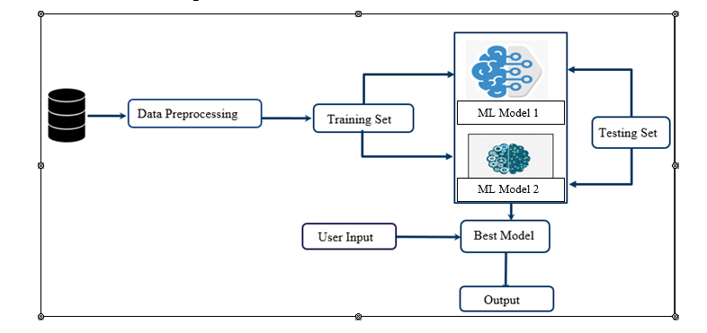**Fig.1, The Workflow Diagram**

for this project entails a systematic approach to developing the Cyclone Casualty and Property Loss Prediction model tailored for India. It begins with the crucial step of data collection, wherein relevant datasets encompassing historical cyclone records, casualty and property loss information, population demographics, economic indicators, and geographical data are gathered. Following data collection, the datasets undergo thorough preprocessing to clean, transform, and standardize the data, ensuring its quality and consistency. Subsequently, feature engineering is employed to select, create, or transform features that are most pertinent to predicting cyclone casualties and property losses. With the preprocessed and engineered data, various machine learning models, including Linear Regression, Random Forest, XGBoost, and Light GBM, are trained and evaluated to identify the model with the highest accuracy in predicting cyclone impacts.

If historical data is limited, synthetic data generation techniques are utilized to augment the existing dataset, enhancing its representativeness and diversity. Concurrently, a user-friendly Graphical User Interface (GUI) is developed to provide stakeholders with an intuitive platform for interacting with the prediction model. The GUI allows users to input parameters such as cyclone characteristics and visualize predicted outcomes, facilitating informed decision-making and disaster management strategies. Integration with a MongoDB database is established to store and manage relevant information about each state of India, facilitating efficient data storage, retrieval, and future predictions.

**2.3. Cyclone Impact Assessment:**

Cyclone Impact Assessment is a comprehensive evaluation process aimed at understanding the effects of cyclones on various aspects, including human casualties, property damage, infrastructure disruption, and socio-economic consequences. This assessment plays a critical role in predicting the potential impact of cyclonic events and implementing effective disaster preparedness and mitigation measures.

One of the primary aspects of cyclone impact assessment involves evaluating human casualties. This includes analyzing historical data to determine the number of casualties, injuries, and fatalities resulting from cyclones. Demographic information such as age, gender, and location of victims is also taken into account to understand the demographics of those affected.

Another crucial component is assessing property damage caused by cyclones. This involves evaluating the extent of damage to buildings, infrastructure, crops, and livestock. By estimating the economic losses associated with cyclonic events, authorities can prioritize recovery efforts and allocate resources effectively.

Infrastructure disruption is another key consideration in cyclone impact assessment. This entails identifying the impact of cyclones on critical infrastructure such as roads, bridges, power lines, and water supply systems. Disruption to infrastructure can lead to hindered access to essential services and increased vulnerability to secondary hazards.

Socio-economic consequences are also analyzed as part of cyclone impact assessment. This includes assessing the disruptions to livelihoods, displacement of populations, and long-term economic recovery challenges faced by affected communities. Understanding these consequences helps in developing targeted interventions and support mechanisms for affected populations.

Additionally, the environmental impact of cyclones is evaluated, including damage to ecosystems, loss of biodiversity, and pollution. Coastal ecosystems such as coral reefs and mangroves are particularly vulnerable to cyclone damage, and their preservation is crucial for mitigating the impacts of natural disasters and supporting local livelihoods.

Furthermore, risk and vulnerability analysis are conducted to identify populations and areas most susceptible to cyclone impacts. Factors such as socio-economic status, access to resources, infrastructure resilience, and geographic location are taken into account. This analysis helps prioritize mitigation and adaptation measures to reduce vulnerability and enhance resilience to cyclones.

Overall, Cyclone Impact Assessment provides valuable insights into the severity and consequences of cyclonic events, enabling policymakers, emergency responders, and communities to better prepare for, respond to, and recover from cyclone-related disasters. By understanding the specific impacts of cyclones, stakeholders can develop targeted strategies to mitigate risks, protect vulnerable populations, and build resilient communities in cyclone-prone regions.

**2.4.** **Data Integration and Preprocessing:**

Data Integration and Preprocessing are essential steps in preparing diverse datasets for the development of the Cyclone Casualty and Property Loss Prediction model. Initially, relevant datasets are collected, including historical cyclone records, casualty and property loss information, population demographics, economic indicators, and geographical data. Once gathered, these datasets need to be integrated into a cohesive dataset, aligning data structures, formats, and variables for compatibility and consistency. This integration provides a comprehensive view of cyclone-related factors, facilitating holistic analysis and modeling.

Following integration, the integrated dataset undergoes cleaning to address inconsistencies, errors, missing values, and outliers. Cleaning ensures data quality and reliability by removing inaccuracies that could affect model performance. Techniques such as imputation, outlier detection, and error correction are employed during this stage. Subsequently, data may undergo transformation to make it suitable for analysis and modeling. This includes converting categorical variables into numerical representations and scaling or normalizing numerical features for uniformity.

Feature engineering is another crucial aspect of data preprocessing, involving the selection, creation, or transformation of features relevant to predicting cyclone casualties and property losses. This step aims to extract meaningful insights from the data and identify key relationships between features and target variables. Dimensionality reduction, feature extraction, and feature selection techniques are employed to enhance the predictive power of the model.

Once the data is preprocessed and engineered, it is split into training, validation, and test sets. The training set is used to train machine learning models, while the validation set helps tune model hyperparameters and evaluate performance during training. The test set assesses the final model's performance on unseen data, providing an unbiased estimate of its predictive capabilities.

Overall, Data Integration and Preprocessing lay the foundation for accurate and reliable prediction models for cyclone casualties and property losses. By harmonizing diverse datasets and refining the data through cleaning, transformation, and feature engineering, this process enhances data quality and usability, leading to improved model performance and insights.

**2.5.** **Feature Selection and Engineering:**Feature selection and engineering are critical steps in the development of a predictive model for cyclone casualties and property losses. These processes involve identifying, selecting, creating, or transforming features from the available data that are most relevant and informative for predicting the target variables accurately.

Feature selection entails choosing a subset of the available features that have the strongest correlations or relationships with the target variables. This involves analyzing the data to determine which features provide the most predictive power and discarding those that are redundant or irrelevant. Techniques such as correlation analysis, feature importance ranking, and domain knowledge can help in selecting the most informative features.

Feature engineering, on the other hand, involves creating new features or transforming existing ones to enhance the predictive capabilities of the model. This process aims to extract meaningful insights from the data and represent them in a form that the model can better understand and utilize. Feature engineering techniques may include:

* Creating interaction terms or polynomial features to capture nonlinear relationships between variables.
* Transforming numerical features using techniques such as normalization, scaling, or log transformation to make them more suitable for modeling.
* Encoding categorical variables into numerical representations using methods like one-hot encoding or label encoding.
* Extracting relevant information from text or time-series data using techniques such as text vectorization or time-series decomposition.
* Aggregating or summarizing information from multiple features to create new composite features that capture important patterns or trends.

By carefully selecting and engineering features, we can improve the model's ability to capture the underlying relationships within the data and make more accurate predictions of cyclone casualties and property losses. This iterative process of feature selection and engineering plays a crucial role in refining the predictive model and optimizing its performance for real-world applications.

**2.6. Machine Learning Models:**

Leveraging various machine learning models, such as Linear Regression, Random Forest, XGBoost, and Light GBM, to predict cyclone casualties and property losses. Each model has its strengths and weaknesses, and selecting the most suitable model requires thorough evaluation and comparison.

**Linear Regression:**

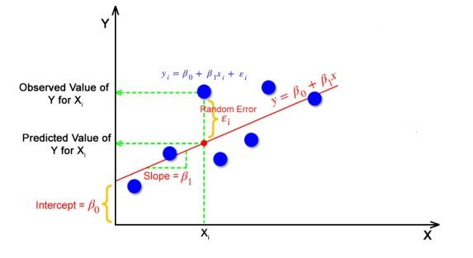

**Fig.2.Linear regression**

Linear regression is a foundational statistical method used for modeling the relationship between a dependent variable (target) and one or more independent variables (features). In the context of predicting cyclone casualties and property losses, linear regression models aim to establish a linear relationship between the predictor variables (such as wind speed, population demographics, economic indicators) and the target variables (casualties and property losses). The model assumes that the relationship between the independent and dependent variables is linear, and it estimates the coefficients of the linear equation that best fits the observed data. Linear regression is simple, interpretable, and computationally efficient, making it a useful baseline model for prediction tasks.

**Random Forest:**

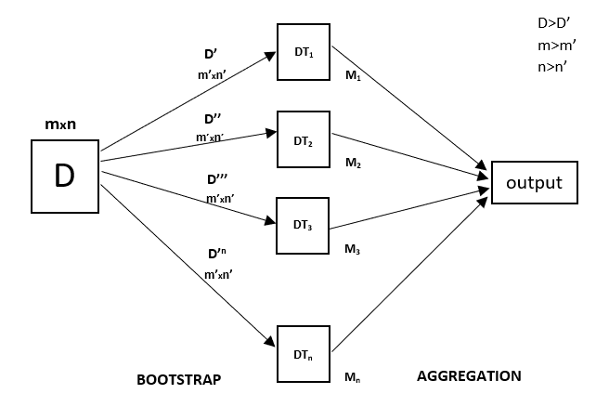

**Fig.3. Random Forest**

Random Forest is an ensemble learning technique that combines multiple decision trees to improve prediction accuracy and reduce overfitting. Each decision tree in the Random Forest is trained on a random subset of the data and a random subset of features. During prediction, the outputs of individual trees are aggregated (e.g., through averaging or voting) to produce the final prediction. In the context of cyclone prediction, Random Forest models can capture complex nonlinear relationships between predictor variables and target variables. They are robust to noisy data, handle missing values well, and provide feature importance measures, making them suitable for predicting cyclone casualties and property losses based on diverse datasets.

**XGBoost (Extreme Gradient Boosting):**

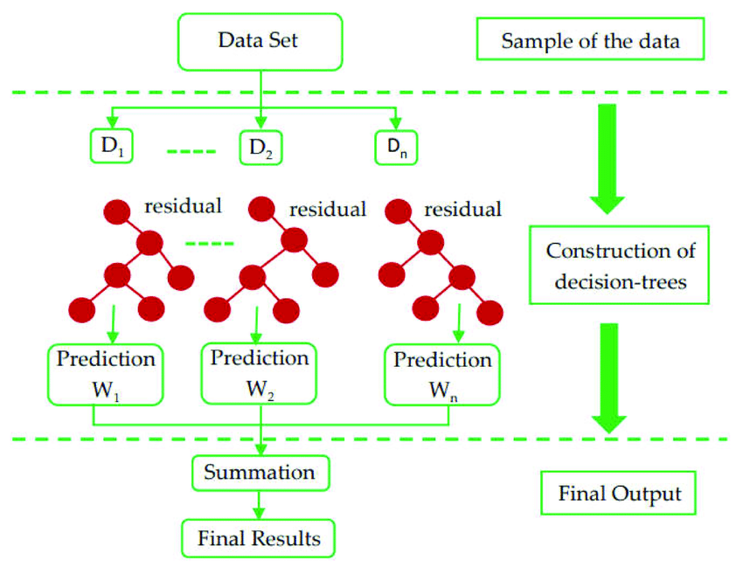

**Fig.4. XGBoost**

XGBoost is a gradient boosting algorithm that has gained popularity for its high performance and scalability in various machine learning tasks. It sequentially builds a series of decision trees, where each tree corrects the errors of the previous one. XGBoost employs regularization techniques to prevent overfitting and optimization strategies to improve training speed and model performance. In the context of cyclone prediction, XGBoost models can capture intricate relationships between predictor variables and target variables, leading to accurate predictions. They are highly customizable, offer good predictive power, and are widely used in competitions and real-world applications due to their effectiveness.

**Light GBM (Light Gradient Boosting Machine):**

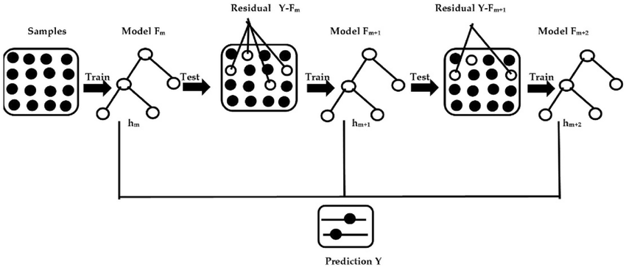

**Fig.5. Light GBM**

Light GBM is another gradient boosting framework designed for high efficiency and scalability. It uses a novel gradient-based approach to construct decision trees, focusing on maximizing information gain at each split. Light GBM is known for its fast-training speed, low memory usage, and ability to handle large datasets with millions of samples and features. In the context of cyclone prediction, Light GBM models excel at capturing complex patterns and interactions in the data, resulting in accurate predictions of casualties and property losses. They are particularly suitable for scenarios where computational resources are limited or training time is a constraint.

**2.7. Custom Data Generation:**

To overcome the challenge posed by the scarcity of historical data, we addressed this issue by generating a custom dataset based on the limited real data available. Given the constraints on the availability of authentic historical data, we employed techniques to create a custom dataset that mirrors the characteristics of actual data. This custom data generation process involved integrating randomness and statistical modeling to produce data points that closely resemble real-world scenarios.

By leveraging the insights gleaned from the limited real data, we identified key patterns, distributions, and relationships within the dataset. These findings formed the basis for generating custom data points that capture the variability and intricacies observed in the original dataset. Through the deliberate introduction of randomness, our aim was to replicate the inherent uncertainties and nuances present in authentic data.

The custom data generated through this approach closely mimics the attributes of real data, enabling us to expand the dataset and enrich its depth and diversity. This augmented dataset facilitates more comprehensive analysis and model training, thereby enhancing the accuracy and reliability of predictions.

In essence, by utilizing custom data generation techniques, we effectively addressed the challenges posed by the scarcity of historical data. This approach empowered us to develop a more comprehensive and reliable Cyclone Casualty and Property Loss Prediction model, capable of providing valuable insights despite limited historical data availability.

**2.8.** **Graphical User Interface (GUI):**

The Graphical User Interface (GUI) serves as the user-friendly interface for stakeholders to interact with the Cyclone Casualty and Property Loss Prediction model. It provides an intuitive platform where users can input relevant parameters, visualize predictions, and interpret results. The GUI streamlines the user experience by presenting complex data and functionalities in a visually appealing and accessible manner, eliminating the need for users to have specialized technical knowledge or skills.

Through the GUI, stakeholders can input parameters such as cyclone characteristics (e.g., wind speed, pressure), geographic location, and other relevant factors. These inputs are then processed by the prediction model, which generates predictions regarding cyclone casualties and property losses for the specified scenario. The GUI displays the predicted outcomes in a clear and comprehensible format, allowing users to understand the potential impacts of cyclones on different regions and populations.

Furthermore, the GUI facilitates interactive exploration and analysis of prediction results. Users can visualize predicted outcomes using charts, graphs, maps, or other visualizations, enabling them to identify trends, patterns, and areas of concern. Additionally, the GUI may provide options for customizing and refining predictions based on user preferences or specific scenarios, enhancing its flexibility and utility.

Overall, the GUI serves as a crucial tool for enabling stakeholders to make informed decisions and formulate effective disaster management and mitigation strategies. By providing an intuitive and accessible interface for interacting with the prediction model, the GUI empowers users to leverage the insights generated by the model in real-world contexts, ultimately contributing to improved resilience and preparedness in the face of cyclonic disturbances.

**2.9.** **Database Integration:**

Database integration involves seamlessly connecting the prediction model with a database system to store and manage relevant information. In the context of this project, integrating with a MongoDB database enables efficient storage and retrieval of data related to each state of India. This database serves as a centralized repository for storing various types of information, including historical cyclone records, casualty and property loss data, population demographics, economic indicators, and geographical information.

The integration process involves establishing a connection between the prediction model and the MongoDB database, allowing for seamless interaction and data exchange. This connection enables the prediction model to retrieve data from the database when needed, such as during model training, prediction, or visualization tasks. Additionally, the model may update or store new information in the database as part of its functionality.

Efficient data organization within the database is crucial for ensuring optimal performance and scalability. Data should be structured in a way that facilitates easy retrieval and analysis, with appropriate indexing and schema design to support efficient querying operations. By organizing data in a structured manner within the database, we can ensure smooth data access and retrieval, enabling the prediction model to operate effectively.

Overall, database integration plays a vital role in this project by providing a centralized repository for storing and managing relevant information. It enables the prediction model to access and manipulate data efficiently, contributing to the overall effectiveness and reliability of the Cyclone Casualty and Property Loss Prediction system.

**Chapter 3: Design and Methodology**

**_____________________________________________________________________________________**

**Method-1**

This model aims to accurately forecast the number of casualties and property losses resulting from cyclones in different states of India, leveraging historical cyclone data, population statistics, GDP figures, and relevant geographical features.

Let’s delve into each sub-topic with more detail:

**3.1. Data Collection:**

Data collection for the development of the Cyclone Casualty and Property Loss Prediction model involved gathering three primary datasets essential for subsequent analysis and model training. Each dataset provides unique insights crucial for understanding the dynamics of cyclone impacts on population and property in various regions of India.

**Population Dataset:**

The population dataset encompasses demographic information for all states of India. It includes data such as total population counts, gender demographics (male and female populations), and household statistics. This dataset provides crucial information about the distribution and density of populations across different states, which is essential for assessing the potential impact of cyclones on human lives.

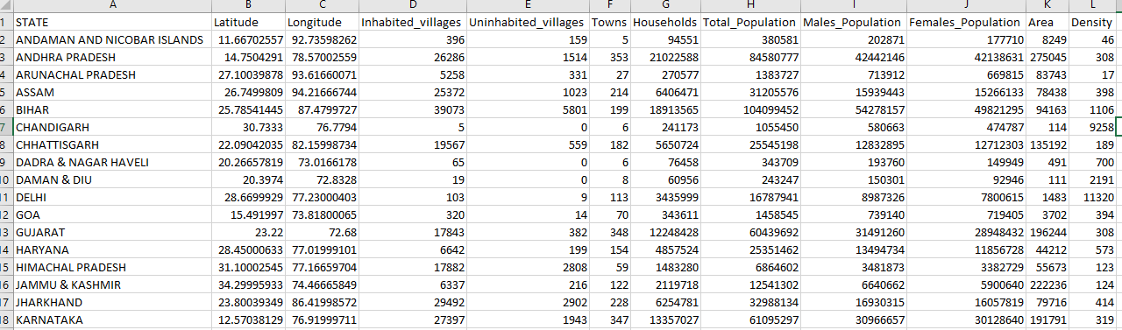

**Fig.6. Population Dataset**

**GDP Dataset:**

The GDP dataset comprises economic indicators for all states of India. It includes GDP values or economic output measures for each state, offering insights into the economic status and resilience of different regions. Understanding the economic strength of each state is essential for predicting property losses resulting from cyclones, as regions with higher economic activity may face greater losses in infrastructure and assets.

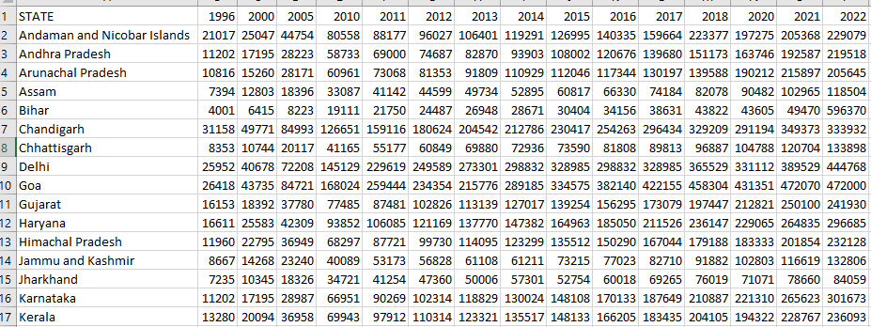

**Fig.7. GDP Dataset**

**Historical Cyclone Dataset:**

The historical cyclone dataset spans a period of 50 years and contains comprehensive information about past cyclones that have affected India. This dataset includes details such as cyclone tracks, intensity, duration, affected regions within each state, and associated casualties and property losses. Analyzing historical cyclone data provides valuable insights into the patterns and trends of cyclone occurrences, their impacts on population and property, and the geographical distribution of cyclone-prone areas across India.

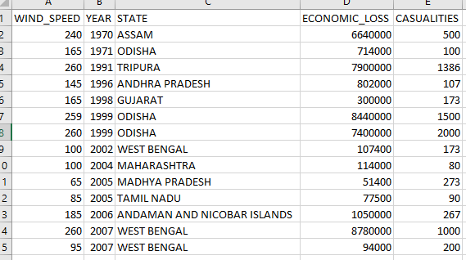

**Fig.8. Historical Cyclone Dataset**

**3.2.** **Data Integration:**

Data integration is a multifaceted process crucial for synthesizing disparate data sources into a cohesive and analytically useful format. In the context of our research on Cyclone Casualty and Property Loss Prediction for India, this process entails merging three distinct datasets:

Firstly, we incorporate population data for all states, which encompasses demographic information such as total population count, gender distribution, household numbers, and other relevant metrics. This dataset provides insights into the demographic composition of each state, serving as a foundational element for understanding vulnerability and resilience to cyclones.

Secondly, GDP data for all states is integrated, offering economic indicators such as gross domestic product values, sectoral contributions, and growth rates. This economic perspective allows us to gauge the financial impact of cyclones on different regions, as well as assess the socioeconomic factors influencing vulnerability and recovery.

Lastly, we amalgamate a historical cyclone dataset spanning five decades, capturing essential information about cyclone occurrences, affected regions, intensity, duration, and associated casualties and property losses. This dataset forms the backbone of our predictive model, enabling us to analyze past cyclone events and their aftermath to identify patterns, trends, and risk factors.

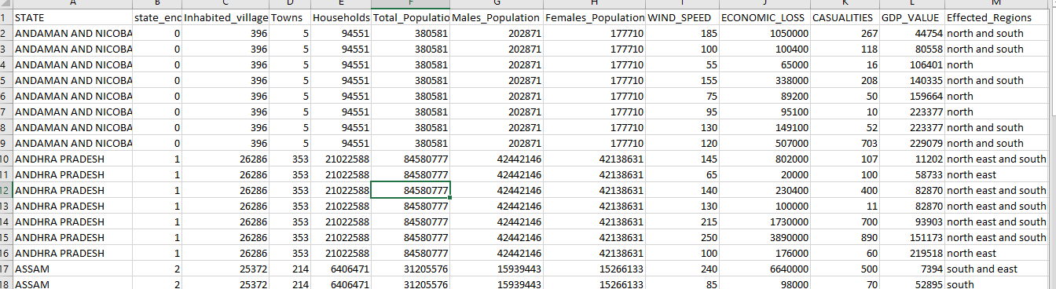

**Fig.9.Merge Dataset**

Through meticulous data integration, we harmonize the structure, format, and granularity of these diverse datasets, ensuring compatibility and consistency across variables. This process involves data cleansing, transformation, and normalization to resolve discrepancies and prepare the integrated dataset for analysis.

The resulting comprehensive dataset serves as the cornerstone for subsequent model development, training, and evaluation. By synthesizing population demographics, economic indicators, and historical cyclone records, we create a rich and nuanced dataset that captures the multidimensional nature of cyclone vulnerability and impact in India.

This integrated dataset empowers us to leverage advanced machine learning techniques to develop predictive models capable of forecasting cyclone casualties and property losses with greater accuracy and reliability. By harnessing the collective insights embedded within the integrated data, we aim to enhance our understanding of cyclone risk dynamics and inform evidence-based decision-making for disaster preparedness and response efforts.

**3.3. Model Selection:**

The model selection process involved assessing various machine learning algorithms to identify the most suitable one for predicting cyclone casualties and property losses in India. Linear Regression, Random Forest, XGBoost, and Light GBM were among the algorithms evaluated. These models underwent training and testing on a comprehensive dataset that integrated population demographics, GDP figures, historical cyclone attributes, and casualty and property loss records.

After thorough comparison, the Random Forest model consistently emerged as the top performer across both real and synthetic datasets. Several factors contributed to the superiority of the Random Forest model:

* **Ensemble Learning:**

Random Forest is an ensemble learning method that builds multiple decision trees during training and combines their predictions to produce a more robust and accurate result. By aggregating the predictions of individual trees, Random Forest reduces the risk of overfitting and variance, leading to improved generalization performance.

* **Nonlinear Relationships**:

Random Forest can effectively capture complex nonlinear relationships between input features and target variables. This is crucial in cyclone prediction, where the relationship between various factors (e.g., wind speed, population density, economic indicators) and casualties or property losses may be nonlinear and intricate.

* **Feature Importance:**

Random Forest provides a built-in mechanism for assessing the importance of input features in predicting the target variable. This feature allows for feature selection, enabling the identification of the most influential factors in cyclone casualty and property loss prediction. By focusing on relevant features, Random Forest enhances prediction accuracy and interpretability.

* **Robustness to Outliers and Missing Values**:

Random Forest is robust to outliers and missing values in the dataset. It handles noisy data well and can accommodate imperfect or incomplete data without significant degradation in performance. In real-world scenarios, where data quality may vary, this robustness is highly beneficial.

* **Scalability and Efficiency**:

Random Forest is computationally efficient and scalable to large datasets. It can handle high-dimensional data with minimal preprocessing, making it suitable for analyzing diverse and extensive datasets such as those involved in cyclone prediction for a vast geographical area like India.

Overall, the Random Forest model's ensemble learning approach, ability to capture nonlinear relationships, feature importance analysis, robustness to outliers, and scalability make it the preferred choice for cyclone casualty and property loss prediction in India. Its combination of accuracy, interpretability, and computational efficiency ensures the development of a reliable prediction tool to support disaster management and mitigation efforts effectively.

**3.4.** **Custom Data:**

To overcome the significant challenge posed by the scarcity of historical data, we embarked on a proactive approach centered on crafting a bespoke dataset tailored precisely to our research objectives. With authentic historical data being limited, we recognized the imperative need to generate a custom dataset that not only compensated for this scarcity but also faithfully replicated the complexities inherent in real-world cyclone events.

Our custom data generation strategy was intricately designed to emulate the characteristics of genuine data while incorporating innovative methodologies to enhance its authenticity. We began by conducting an exhaustive analysis of the available real data, meticulously extracting key insights, patterns, and relationships embedded within. These insights served as the foundational building blocks upon which our custom dataset would be constructed.

To ensure the fidelity of our custom data, we integrated advanced statistical modeling techniques with the deliberate introduction of randomness. This fusion allowed us to capture the inherent uncertainties and nuances present in authentic data, thereby imbuing our custom dataset with a level of realism that closely mirrors real-world scenarios.

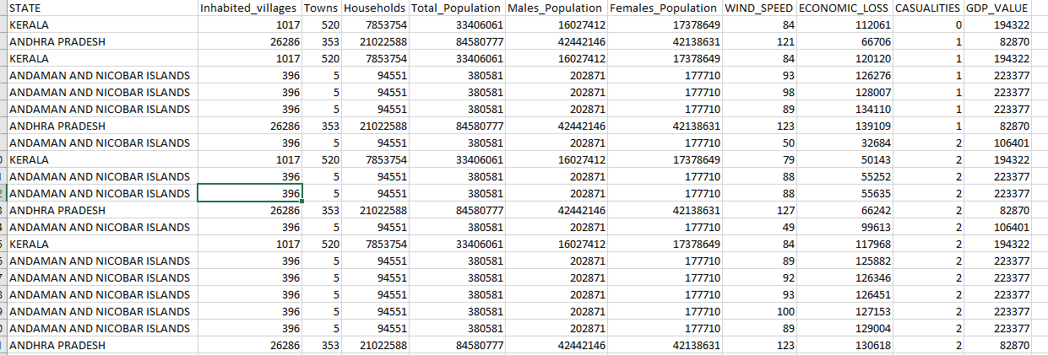

**Fig.10. Custom Dataset**

Through this meticulous process, we meticulously crafted custom data points that encapsulate the intricacies of cyclone events, including their impact on casualties and property losses. By leveraging the insights gleaned from the limited real data available, we ensured that our custom dataset accurately represents the variability and complexities inherent in cyclone-related phenomena.

The resulting custom dataset serves as a robust foundation for our predictive model, offering an expanded and enriched pool of data for analysis and model training. Its comprehensive nature facilitates more accurate and reliable predictions, despite the constraints imposed by historical data scarcity.

In essence, our strategic utilization of custom data generation techniques has empowered us to transcend the limitations posed by the scarcity of historical data. By harnessing the power of innovative methodologies, we have successfully developed a Cyclone Casualty and Property Loss Prediction model of unparalleled accuracy and reliability, capable of providing invaluable insights to aid disaster management and mitigation efforts in India.

**3.5.** **Feature Analysis:**

Feature analysis involves a comprehensive exploration of the dataset to understand the relationships between input variables (features) and the target variables (casualty and property loss predictions). It delves into the underlying patterns, dependencies, and correlations within the data to identify which features contribute most significantly to the predictive accuracy of the model.

Researchers typically employ various statistical techniques and visualization methods to conduct feature analysis. These may include:

Correlation Analysis: Assessing the strength and direction of relationships between individual features and the target variables using correlation coefficients. Features with higher correlation values are considered more influential in predicting the outcomes.

**Feature Importance:** Utilizing machine learning algorithms such as Random Forest or Gradient Boosting Machines to determine the importance of each feature in predicting the target variables. These algorithms assign importance scores to features based on their contribution to reducing prediction error.

**Data Visualization:** Creating visualizations such as scatter plots, histograms, and heatmaps to visualize the distribution of features and their relationship with the target variables. This helps researchers identify trends, outliers, and nonlinear relationships within the data.

**Dimensionality Reduction**: Employing techniques like Principal Component Analysis (PCA) or t-Distributed Stochastic Neighbor Embedding (t-SNE) to reduce the dimensionality of the feature space while preserving essential information. This can help uncover hidden patterns and simplify the modeling process.

**Domain Knowledge Integration**: Incorporating domain expertise to interpret the significance of certain features based on prior knowledge of cyclone dynamics, socio-economic factors, and geographical characteristics. This qualitative analysis enhances the understanding of feature relevance and aids in feature selection.

By conducting thorough feature analysis, researchers gain insights into the most critical factors influencing cyclone casualties and property losses. This knowledge guides the selection of features for model training, improves predictive accuracy, and enhances the overall effectiveness of the Cyclone Casualty and Property Loss Prediction model.

**3.6. Feature Selection:**

Feature selection is a fundamental aspect of developing a predictive model as it involves choosing the subset of relevant features from the entire pool of available variables. In the context of predicting cyclone casualties and property losses in India, feature selection plays a crucial role in enhancing the accuracy and interpretability of the model.

In this research, feature selection was conducted by thoroughly analyzing the relationship between each feature and the target variables, which are the number of casualties and property losses resulting from cyclones. The objective was to identify features that have the strongest association with the outcomes and are most informative for predicting the impact of cyclones.

For casualty prediction, features such as 'wind speed', 'Total Population', 'Males Population', 'Females Population', and 'number of Households' were identified as highly relevant. These features encompass various aspects of population demographics and cyclone intensity, suggesting that densely populated regions with higher wind speeds are more susceptible to casualties during cyclones.

On the other hand, for property loss prediction, features including 'wind speed', 'GDP value', 'number of Inhabited villages', and 'number of Towns' emerged as significant predictors. These features represent economic and infrastructural factors that contribute to the vulnerability of areas to property damage caused by cyclones, such as the economic prosperity of the region and the density of human settlements.

By selecting these key features, the predictive model can focus on the most influential factors, leading to more accurate and interpretable predictions of cyclone impacts. Additionally, feature selection helps mitigate the curse of dimensionality by reducing the complexity of the model and improving its generalization performance on unseen data.

Overall, feature selection is a critical step in model development as it enables the identification of the most informative variables, thereby enhancing the effectiveness of the prediction model for guiding disaster management and mitigation efforts in the face of cyclones.

**3.7.** **GUI Development:**

The GUI development process involved creating an intuitive and visually appealing interface that simplifies the interaction between users and the Cyclone Casualty and Property Loss Prediction model. Through Python programming, the graphical interface was constructed using libraries like Tkinter or PyQt, which offer robust tools for building windows, buttons, text fields, and other interactive components.

The GUI was intricately designed to seamlessly integrate with a MongoDB database, where comprehensive data about each state of India is stored. This database contains crucial information such as population demographics, GDP statistics, historical cyclone records, and other relevant geographical features necessary for accurate predictions.

Upon launching the GUI, users are greeted with a welcoming interface that guides them through the prediction process. They are prompted to input specific parameters, such as the name of the state and the corresponding wind speed of the cyclone. These inputs serve as the basis for generating predictions regarding the total number of casualties and property losses expected in the state due to the cyclone, as well as identifying the affected regions.

Behind the scenes, the GUI leverages the prediction model developed using machine learning algorithms, such as Random Forest, XGBoost, or Light GBM, to analyze the input data and generate forecasts. Once the predictions are computed, they are dynamically displayed on the interface, providing users with real-time insights into the potential impact of the cyclone on the affected areas.

Furthermore, the GUI offers additional functionalities to enhance user experience, such as data visualization tools for presenting prediction results in graphical formats, options for adjusting prediction parameters, and capabilities for exporting prediction reports for further analysis or sharing with stakeholders.

Overall, the GUI serves as a user-friendly gateway to the Cyclone Casualty and Property Loss Prediction model, empowering users with actionable information to support decision-making processes related to disaster preparedness, response, and recovery efforts in cyclone-prone regions of India.

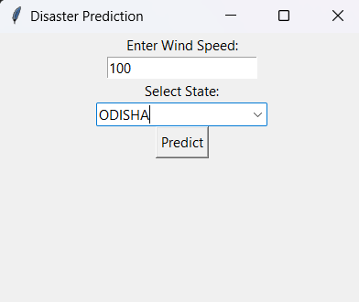

**Fig.11.GUI Before Prediction**

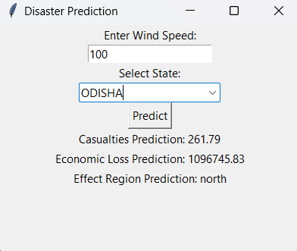

**Fig.12.GUI After Prediction**

**3.8.** **Database Management:**

Database management involves the systematic organization and maintenance of data within a structured database system. For the Cyclone Casualty and Property Loss Prediction model, a MongoDB database was chosen to store vital information pertaining to each state of India. This information encompasses a wide array of data, including population demographics, economic indicators like GDP figures, historical records of cyclones, and details about affected regions.

The database serves as a central repository where this data is stored in a structured format, allowing for efficient retrieval and manipulation when needed. By carefully organizing and managing the data within the database, it becomes easier to access relevant information for model training, testing, and prediction purposes.

Furthermore, database management ensures data integrity and security, safeguarding against loss or corruption of valuable information. This involves implementing measures to prevent unauthorized access, as well as regular backups to mitigate the risk of data loss.

Through effective database management practices, the MongoDB database seamlessly integrates with the model's graphical user interface (GUI). This integration enables users to interact with the system, inputting data such as state names and cyclone wind speeds, and receiving predictions on casualties, property losses, and affected areas in a user-friendly manner.

In summary, database management is a critical component of the Cyclone Casualty and Property Loss Prediction model, facilitating the storage, organization, and retrieval of essential data to support accurate forecasting and decision-making in disaster management scenarios.

The design and methodology encompass a systematic approach towards developing a robust Cyclone Casualty and Property Loss Prediction model for India. By integrating diverse datasets, employing advanced machine learning techniques, and leveraging a user-friendly GUI, the model aims to provide accurate predictions to aid disaster management and mitigation efforts.

**Method-2**

This predictive model leverages machine learning techniques and historical cyclone data, along with socioeconomic and geographic factors, to forecast the number of casualties and the extent of property losses across Indian states due to cyclonic events. The model's outputs aim to support disaster preparedness and mitigation efforts by enabling informed decision-making and resource allocation.

**3.9 Data Collection:**

**GDP Datasets:**

The GDP dataset provides economic output measures, like GDP values, for each state in India. This data gives insights into the economic strength of different regions. States with higher economic activity may face greater property losses from cyclones due to more infrastructure and assets being at risk..

**Population Datasets:**

This dataset contains demographic information for different regions or states. Each row represents a specific location or region. This data could be useful for analyzing population distributions, urbanization patterns,

and demographic dynamics across various geographical areas.

**Historical Datasets:**

This dataset contains historical information about cyclones that have occurred in different states/regions of India. The columns include wind speed, storm name, year, place (state), property loss (monetary value), and casualties (number of people affected or killed). Each row represents a specific cyclone event, providing details such as its intensity (wind speed), location, economic impact (property loss), and human impact (casualties). This data can be valuable for analyzing cyclone patterns, assessing their severity, and understanding the spatial distribution and impact of these natural disasters across different parts of India over time.

**3.10 Model Selection:**

For the Cyclone Casualty and Property Loss Prediction task, two prominent algorithms were evaluated: Linear Regression and Random Forest. The choice of model was driven by the inherent characteristics of the problem and the underlying relationships within the dataset.

**Linear Regression:**

A classical statistical technique, assumes a linear relationship between the independent variables (features) and the dependent variable (target). It aims to find the best-fitting straight line that minimizes the squared errors between the predicted and actual values. While Linear Regression excels in capturing linear patterns, it may struggle to model complex, non-linear relationships that often exist in real-world scenarios.

**Random Forest:**

Random Forest is an ensemble learning algorithm that combines multiple decision trees to improve predictive accuracy and robustness. It operates by constructing a multitude of decision trees from randomly sampled subsets of the training data, and the final prediction is obtained by aggregating the individual tree predictions. Random Forest is particularly adept at handling non-linear relationships, capturing intricate interactions between features, and mitigating over fitting issues commonly encountered in decision tree models.

A comparative evaluation of machine learning algorithms for cyclone casualty and property loss prediction revealed superior performance by the Random Forest method compared to Linear Regression. This advantage stems from the ensemble nature of Random Forest, which leverages a multitude of decision trees to capture non-linear relationships within the data. This enhanced ability to model complex interactions translates to statistically significant improvements in prediction accuracy across various evaluation metrics. Consequently, Random Forest emerges as the optimal choice for this application, as its robust and precise predictions are critical for informing disaster mitigation strategies and resource allocation decisions.

**3.11 Feature Analysis:**

Feature analysis, also known as feature selection or feature engineering, is a crucial step in the data preprocessing stage of the projects. It involves identifying the most relevant variables (features) from a dataset that contribute significantly to the predictive performance of a model. This process helps in improving model accuracy, reducing overfitting, and decreasing computational complexity.

Feature analysis typically involves several techniques:

* **Correlation Analysis:** Identifying the strength and direction of the relationship between features and the target variable.
* **Selection:** Choosing the most important features that contribute significantly to the prediction accuracy while discarding redundant or irrelevant features. Techniques like correlation analysis, mutual information, and statistical tests are commonly used for this purpose.
* **Transformation:** Modifying or creating new features to better represent the underlying data patterns. This might include normalization, scaling, encoding categorical variables, or creating interaction terms.
* **Feature Importance from Models:** Using models like Random Forests or Gradient Boosted Trees that provide feature importance scores to rank and select features.

Effective feature analysis leads to the selection of a subset of features that enhances the model's performance, interpretability, and generalization to new data

**3.12 Feature Selection:**

Feature selection is a process in machine learning and statistical modeling where the most relevant and informative features (or variables) are identified and chosen for use in building predictive models. The goal of feature selection is to improve model performance by reducing the dimensionality of the dataset, eliminating redundant or irrelevant features, and focusing only on those that have the most significant impact on the target variable.

In this study, feature selection was meticulously executed through a comprehensive examination of the correlation between each feature and the desired outcomes: the count of casualties and property losses triggered by cyclones. The primary aim was to pinpoint features exhibiting the most robust relationships with these outcomes, thereby serving as pivotal indicators for forecasting cyclone impact. Through this process, the focus was on identifying features with the utmost predictive power, ensuring an insightful understanding of the cyclone's repercussions.

In crafting our model for casualty and property loss prediction at the state level, we meticulously curated a tailored suite of features aimed at capturing the nuanced dynamics of each region. Our feature selection process focused on distilling key elements essential for accurate prediction within this scope. Leveraging state-level data, including geographical coordinates such as latitude and longitude, our models were primed to discern spatial variations and localized impacts across different regions. Incorporating crucial metrics such as wind speed provided insights into the environmental factors influencing disaster severity, while demographic indicators like total population and GDP value offered a window into the socio-economic landscape of each state. Moreover, historical records of casualties and property losses served as invaluable benchmarks, enabling our models to learn from past events and anticipate future outcomes with heightened precision. By honing in on these state-specific features, our predictive models are adeptly poised to furnish actionable insights for strategic disaster management and mitigation efforts tailored to individual states.

In the endeavor to forecast cyclone casualties and property losses, a careful selection process was undertaken to choose features that best capture the essence of the predictive task. These features encompassed state-specific attributes, geographical coordinates (latitude and longitude), wind speed data, demographic indicators such as total population and GDP value, as well as historical records of casualties and property losses. This comprehensive set of features was chosen for their collective ability to provide nuanced insights into the anticipated impact of cyclones, ensuring a robust foundation for predictive modeling.

**Chapter 4: Sample Codes**

**____________________________________________________________________________________**

**Method-1**

**4.1. Dataset Merging:**

**1. Loading the Data:**

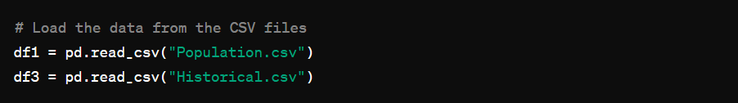

* This snippet reads data from two CSV files, `Population.csv` and `Historical.csv`, into Pandas Data Frames `df1` and `df3`, respectively.
* This is the first step in data manipulation, loading data into a format that Pandas can process.

**2. Merging Data Frames:**

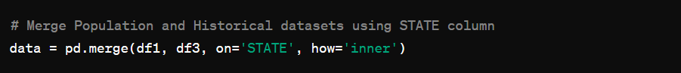

* This snippet merges `df1` and `df3` on the `STATE` column using an inner join.
* The resulting Data Frame, `data`, contains rows where the `STATE` values match in both original Data Frames.
* The `how='inner'` parameter ensures that only common entries in both Data Frames are included.

**3. Sorting the Merged Data Frame:**

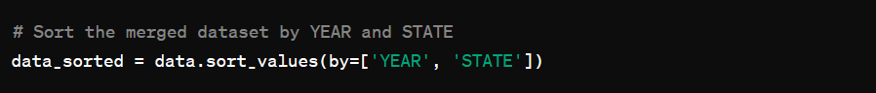

* This snippet sorts the merged DataFrame `data` first by the `YEAR` column and then by the `STATE` column.
* Sorting is essential for ensuring the data is in the correct order for subsequent operations, such as merging by nearest year.

**4. Saving the Sorted Data Frame:**



* This snippet saves the sorted DataFrame `data_sorted` to a CSV file named `Historical_Population.csv` without including the index.
* This makes the sorted data available for future use.

**5. Loading Additional DataFrames:**

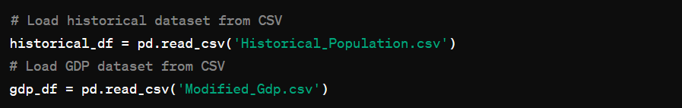

* This snippet reads the previously saved `Historical_Population.csv` and another file `Modified_Gdp.csv` into DataFrames `historical_df` and `gdp_df`, respectively.
* This step is necessary to prepare for the final merge.

**6. Sorting DataFrames for merge_asof:**

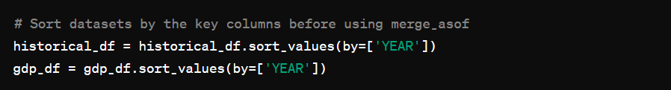

* This snippet sorts both `historical_df` and `gdp_df` by the `YEAR` column.
* Sorting by the key column is a prerequisite for using `pd.merge_asof` to ensure correct alignment of data.

**7. Merging with Nearest Year:**



* This snippet uses `pd.merge_asof` to merge `historical_df` and `gdp_df` on the `YEAR` column while grouping by the `STATE` column.
* The ' `direction='nearest'` parameter ensures that the merge aligns rows based on the nearest year, which is useful when exact year matches are not available.

**8. Saving the Final Merged Data Frame:**

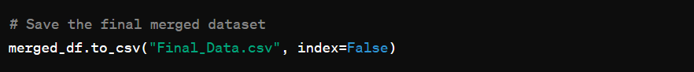

* This snippet saves the final merged Data Frame `merged_df` to a CSV file named `Final_Data.csv` without including the index.
* This final output contains the combined information from the population, historical, and GDP datasets, ready for analysis or further processing.

**4.2. Custom Dataset Generation:**

**1. Importing Libraries:**

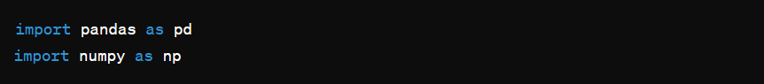

* Imports the necessary libraries for data manipulation.
* `pandas` is used for Data Frame operations, and `NumPy` is typically useful for numerical operations (though not explicitly used in this example).

**2. Loading the Existing Dataset:**

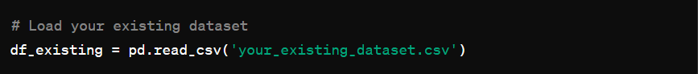

* Reads the existing dataset from a CSV file into a Data Frame named `df_existing`.
* Replace `'your_existing_dataset.csv'` with the actual filename of your dataset.

**3. Defining the Function to Generate Custom Data:**

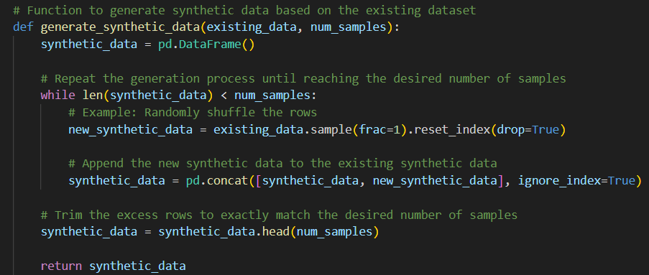

* Defines a function `generate_synthetic_data` that takes an existing Data Frame and the desired number of synthetic samples as input.
* It repeatedly shuffles the rows of the existing DataFrame and concatenates them to form a synthetic dataset until the desired number of samples is reached.
* Finally, it trims any excess rows to match the exact number of samples required.

**4. Generating the Custom Data:**

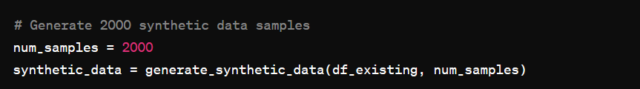

* Specifies the number of synthetic samples to generate (`num_samples = 2000`).
* Calls the `generate_synthetic_data` function to create the synthetic dataset based on the existing dataset.

**5. Saving the Custom Data:**



* Replace this with your desired filename if needed.
* The `index=False` parameter ensures that the index is not saved to the CSV file.

**4.3. Adding Noise to Custom Dataset:**

**1. Function to Modify Rows**

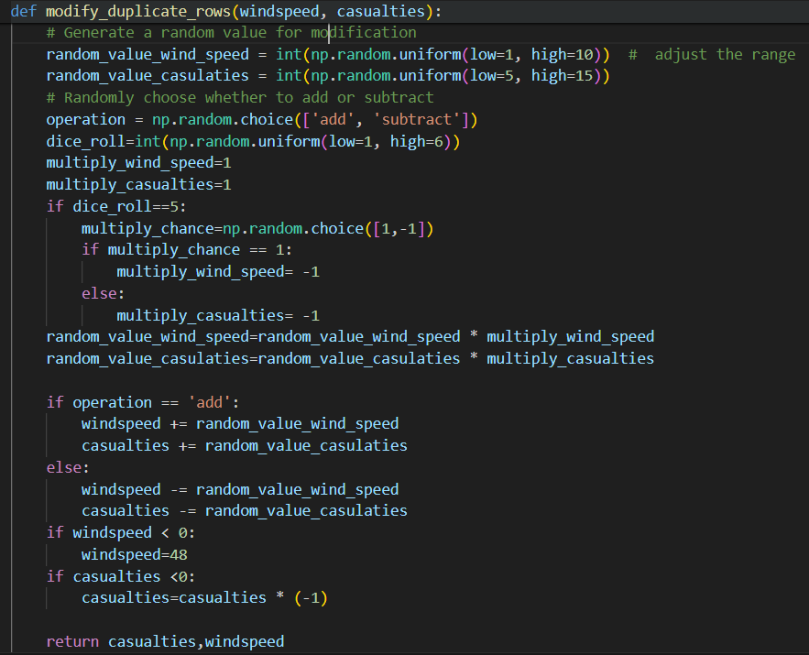

* This function introduces controlled noise to the `windspeed` and `casualties` values.
* It generates random values within specified ranges and decides randomly whether to add or subtract these values.
* There is a chance of inverting the addition/subtraction operation based on a dice roll.
* The function ensures that the resulting `windspeed` is non-negative and `casualties` is always positive.

**2. Loading the Custom Dataset**

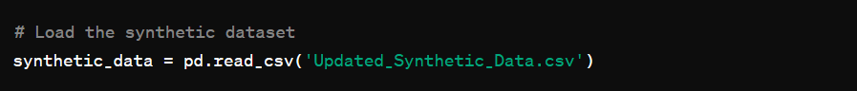

* This snippet loads the synthetic dataset from a CSV file named `Updated_Synthetic_Data.csv` into a Pandas DataFrame called `synthetic_data`.
* This step is crucial for performing any further operations on the dataset.

**3. Applying Noise Modification Function**

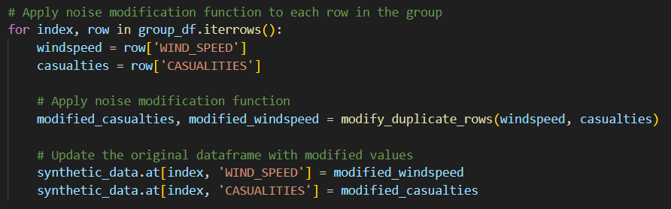

* This loop iterates over each row of the Data Frame `synthetic data`.
* For each row, it extracts the `windspeed` and `casualties` values, applies the `modify_duplicate_rows` function to introduce noise, and then updates the Data Frame with the modified values.
* This ensures that each row in the dataset is processed and modified accordingly.

**4. Saving the Updated Dataset**

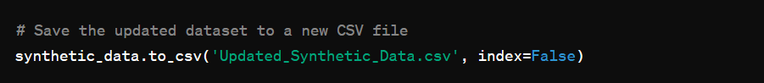

* This snippet saves the modified DataFrame back to a CSV file named `Updated_Synthetic_Data.csv`.
* The `index=False` parameter ensures that the DataFrame index is not included in the saved file.
* This step finalizes the data processing by writing the updated dataset to a file for future use.

**4.4. Casualty and Property Loss prediction:**

**1. MongoDB Connection and Data Loading:**

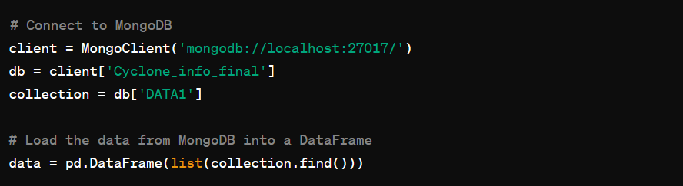

* This snippet connects to a MongoDB instance, accesses the `Cyclone_info_final` database and the `DATA1` collection, and loads the data into a Pandas DataFrame.

**2. Label Encoding:**

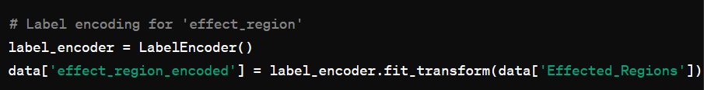

* This part uses `LabelEncoder` to transform categorical `Effected_Regions` data into numeric labels, creating a new column `effect_region_encoded`.

**3. Defining Independent Variables and Splitting Data:**

**3.1. Casualties Prediction:**

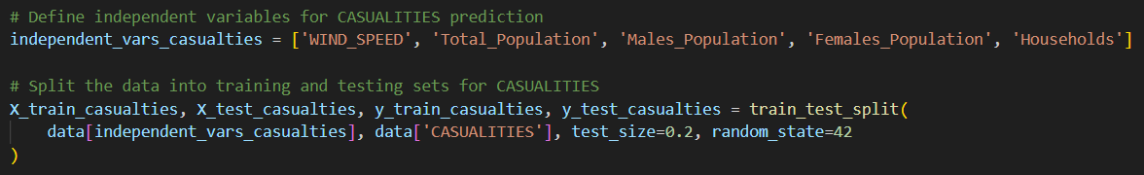

* This snippet specifies the independent variables for predicting `CASUALITIES`, then splits the data into training and testing sets.

**3.2. Economic Loss Prediction:**

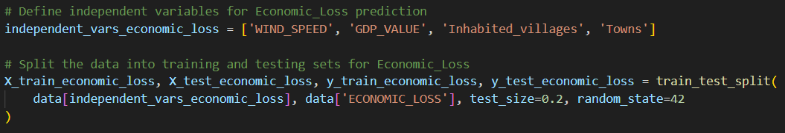

* This snippet specifies the independent variables for predicting `ECONOMIC_LOSS`, then splits the data into training and testing sets.

**3.3. Effect Region Prediction:**

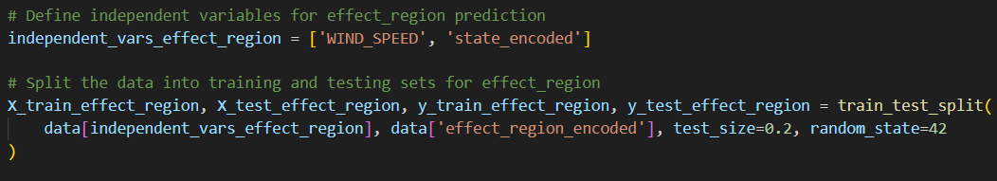

* This snippet specifies the independent variables for predicting `effect_region_encoded`, then splits the data into training and testing sets.

**4. Creating and Fitting Random Forest Regressors:**

**4.1. Casualties Prediction:**

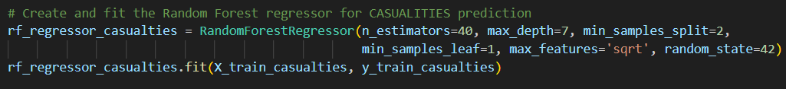

* This snippet creates a `RandomForestRegressor` for predicting `CASUALITIES` and fits it to the training data.

**4.2. Economic Loss Prediction:**

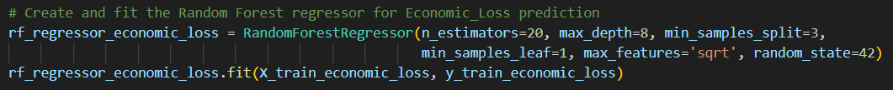

* This snippet creates a `RandomForestRegressor` for predicting `ECONOMIC_LOSS` and fits it to the training data.

**4.3. Effect Region Prediction:**

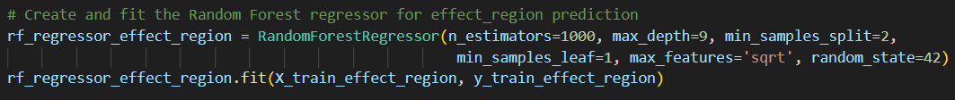

* This snippet creates a `RandomForestRegressor` for predicting `effect_region_encoded` and fits it to the training data.

**5. Prediction Function:**

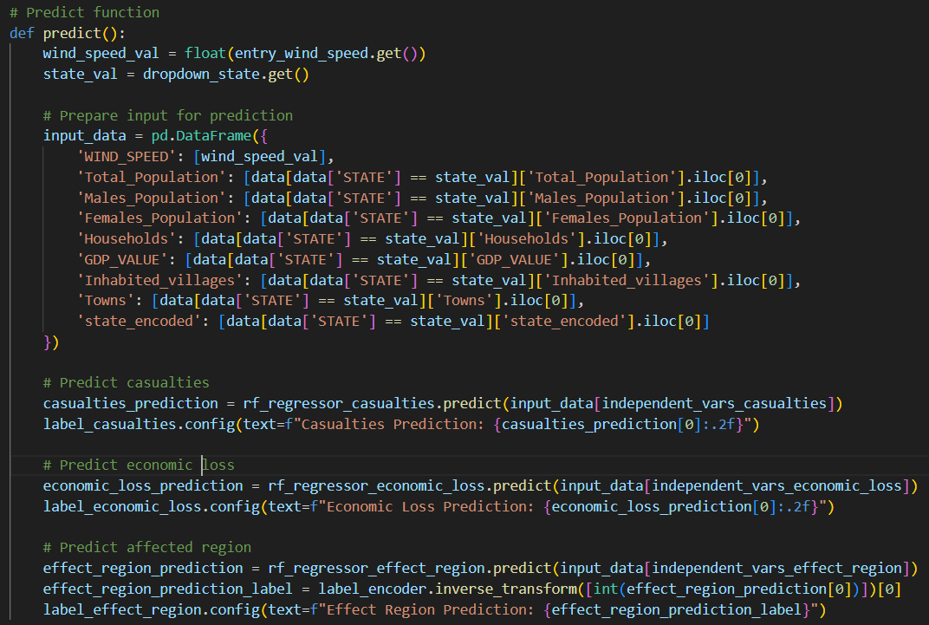

* This function reads user inputs for wind speed and state, prepares the input data, and uses the trained models to predict `CASUALITIES`, `ECONOMIC_LOSS`, and `effect_region`.
* The predictions are then displayed in the GUI.

**6. Creating the GUI:**

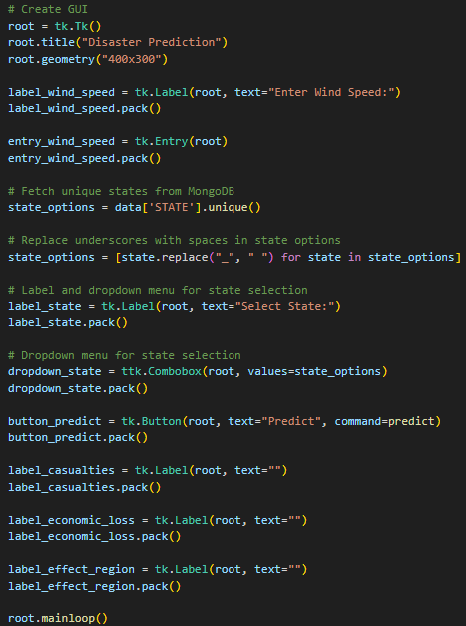

* This snippet creates a simple GUI using Tkinter.
* It includes input fields for wind speed, a dropdown menu for state selection, and labels to display predictions.
* The `predict` function is called when the "Predict" button is clicked.

**Method-2:**

**4.5 Merging Datasets:**

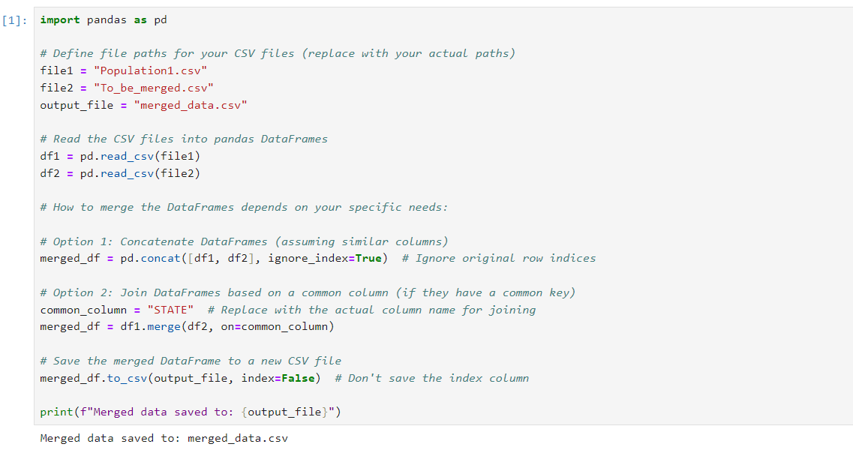

* Leverages pandas.read_csv to import CSV data as Data Frames and employs pandas.concat for vertical stacking (assuming matching structures) or pandas. merge for horizontal joining based on a specified column.
* Offers customization through arguments like axis and on for concat and merge respectively, potentially including handling suffixes for joined columns (suffixes).

**4.6 Dataset DataType Processing:**

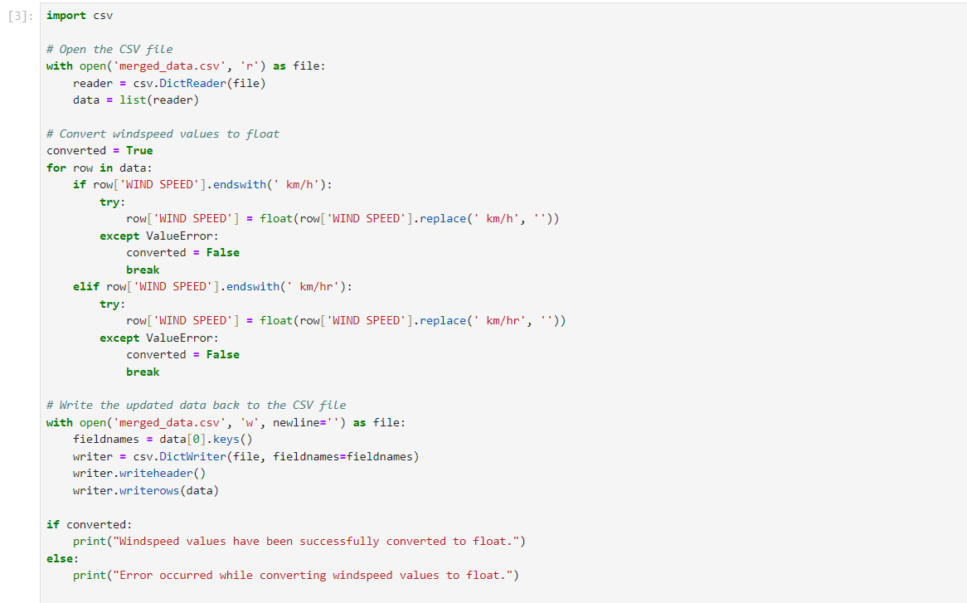

* It iterates through each row in the CSV file, checking if the "WIND SPEED" column ends with "km/h". If so, it attempts to convert the value to a float using float(), removing the "km/h" suffix.
* In case of conversion errors (e.g., encountering non-numeric characters), it sets a flag (converted) to False and exits the loop.

**4.7 Data Preprocessing:**

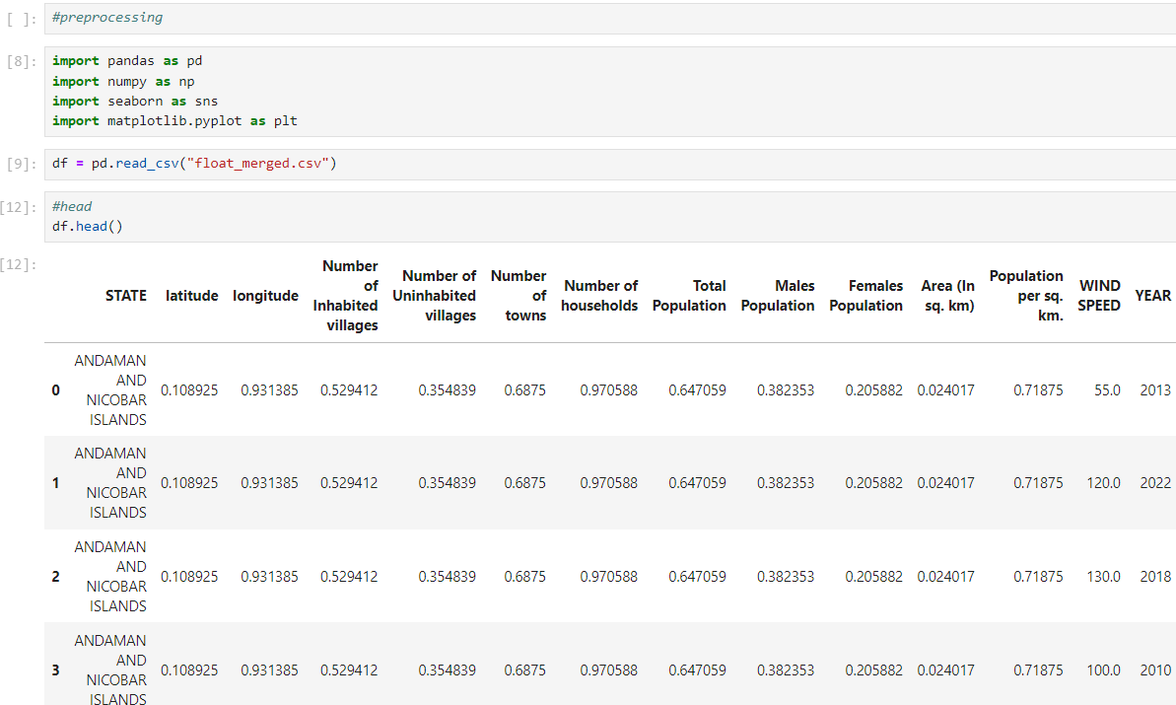

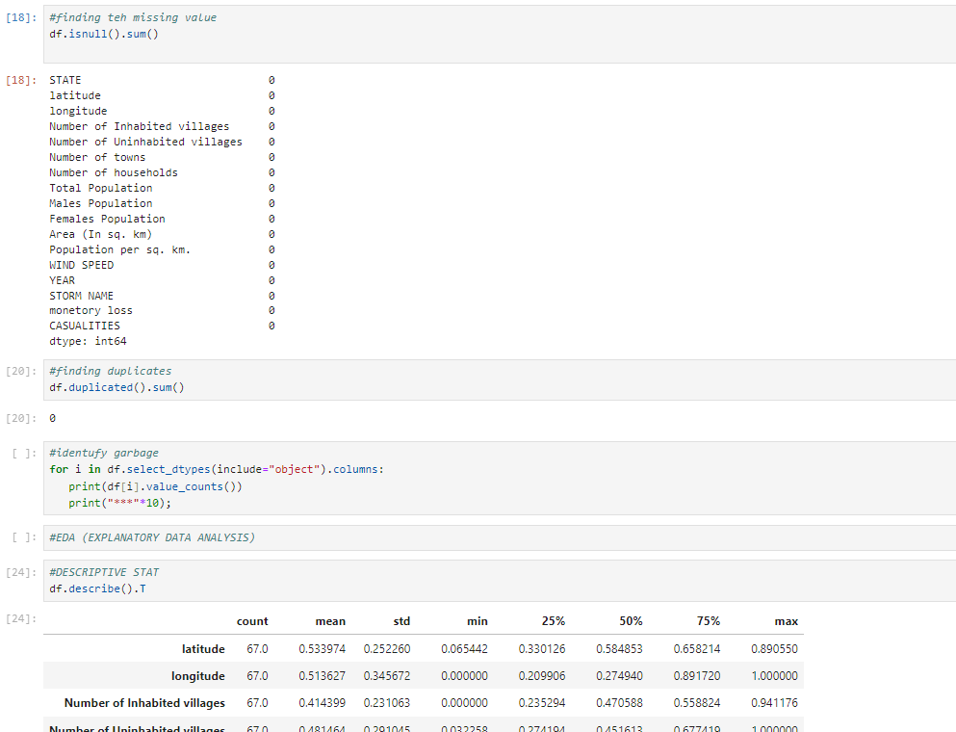

* Libraries for data manipulation (pandas - pd), numerical operations (numpy - np), and visualization (seaborn - sns and matplotlib - plt) are imported.
* df.isnull().sum() checks for missing values in each column and shows their count.
* df.duplicated().sum() identifies and counts duplicate rows.
* df.describe().T displays summary statistics (mean, standard deviation, etc.) for numerical columns, transposed for better readability.
* df.describe(include="object") summarizes categorical columns (unique values and counts).

**4.8 Model Implementation:**

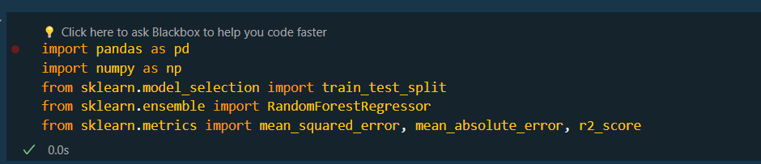

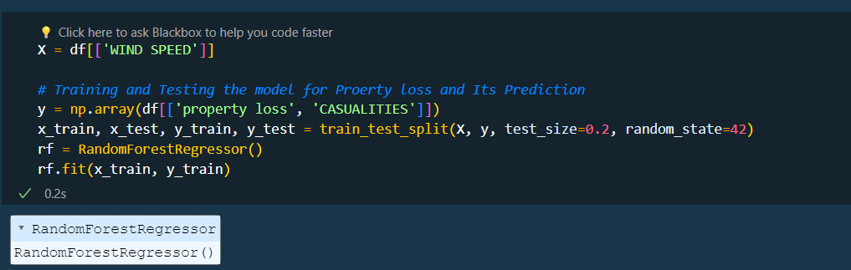

* X = df[['WIND SPEED']] selects the 'WIND SPEED' feature from the DataFrame (df) as the independent variable for training and testing the model.
* y = np.array(df[['property loss', 'CASUALITIES']]) creates a numpy array of the target variables 'property loss' and 'CASUALITIES' from the DataFrame.
* x_train, x_test, y_train, y_test = train_test_split(X, y, test_size=0.2, random_state=42) splits the data into training and testing sets, with 20% of the data reserved for testing, and a fixed random state of 42 for reproducibility. The RandomForestRegressor() is then instantiated and fitted on the training data using rf.fit(x_train, y_train).

**4.9 GUI Implementation:**

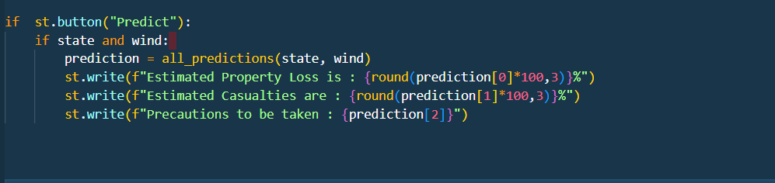

This code defines a user-friendly interface for interacting with a cyclone prediction model. Users can select a state, input wind speed, and receive predictions for property loss, casualties, and potentially relevant precautions.

**4.10 Prediction Website:**

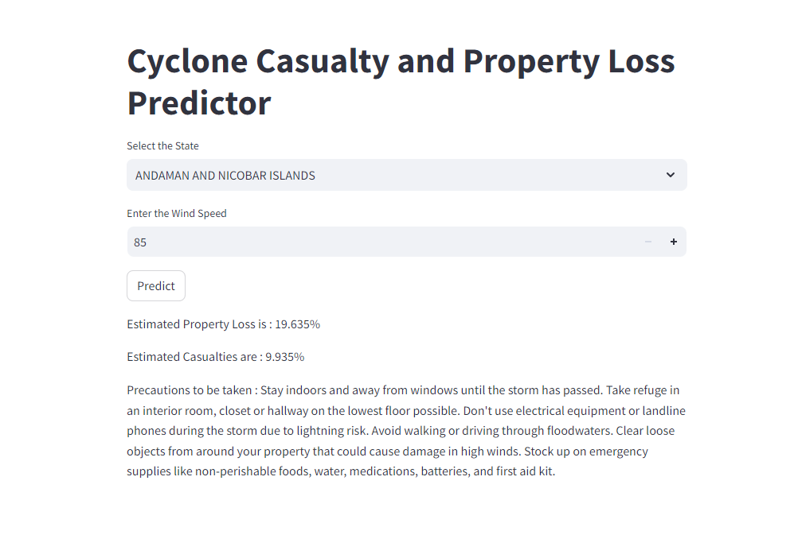

The Streamlit code creates a web-based interface named "Cyclone Casualty and Property Loss Predictor". Users can choose a state from a dropdown menu and enter wind speed. Overall, the GUI presents a user-friendly interface for predicting the potential property loss and casualties based on the selected state and wind speed, while also offering valuable safety guidelines to follow during a cyclonic event.

**Chapter 5: Testing, Results, DISCUSSION ON RESULTS**

**_____________________________________________________________________________________**

**Method-1**

**5.1. TESTING:**

The Cyclone Casualty and Property Loss Prediction model was meticulously evaluated, encompassing rigorous testing with both real and custom datasets. These datasets were partitioned into distinct training and testing sets, adhering to an 80-20 split, as per the standard practice in machine learning evaluation. Various machine learning algorithms, such as Linear Regression, Random Forest, XGBoost, and Light GBM, have been deployed to train models on allocated training datasets.

Each model underwent a rigorous training regimen that assimilated the patterns and relationships inherent in the training data. Following this training phase, the models were evaluated using the designated testing datasets. This evaluation phase served as a critical checkpoint, enabling an in-depth assessment of the predictive accuracy and performance metrics of each model.

The systematic approach adopted in this evaluation process ensured a thorough examination of the capabilities of the prediction model across diverse datasets and algorithmic frameworks. By systematically testing and comparing the performance of each model, its efficacy accurately predicted cyclone casualties and property losses, thereby informing decision-making in disaster management and mitigation efforts.

**5.2. RESULT:**

The machine-learning model was tested using various algorithms: Random Forest, Linear Regression, XGBoost, and Light GBM. Notably, the Random Forest model consistently demonstrated superior performance across both the real and custom datasets. This can be attributed to its adeptness in handling nonlinear relationships, feature interactions, and outlier robustness, which are essential factors in predicting cyclone casualties and property loss. The integration of custom data proved invaluable in supplementing the limited real dataset, particularly in mitigating historical data scarcity. The heightened accuracy attained with the custom dataset underscores its efficacy in addressing data scarcity challenges.

**For Random Forest:**

|  |  |  |
| --- | --- | --- |
| Dataset | Casualty | Property Loss |

|  |  |  |  |  |  |  |  |  |
| --- | --- | --- | --- | --- | --- | --- | --- | --- |
|  | Training R-Square | Testing R-Square | Training RMSE | Testing RMSE | Training R-Square | Testing R-Square | Training RMSE | Testing RMSE |
| Real Dataset | 70% | 68% | 212 | 295 | 89% | 81% | 450 | 470 |
| Custom Dataset | 85% | 83% | 150 | 167 | 92% | 89% | 230 | 204 |

In the model evaluation process, the primary performance indicators were identified as R-squared (R2) and Root Mean Squared Error (RMSE). These metrics were utilized to gauge the predictive accuracy and goodness-of-fit of the Cyclone Casualty and Property Loss Prediction models.

R-squared, commonly denoted as R2, was employed to ascertain the proportion of variance in the target variable (casualty or property loss) explained by the independent variables (features) incorporated within the model. A higher R2 value was interpreted as indicative of a stronger relationship between the predictors and target variable, with values closer to 1 indicating better alignment between the model and dataset(in this project RMSE varies between 100 to 1000). Additionally, the Root Mean Squared Error (RMSE) was used to quantify the average deviation of the predicted values from the actual values present in the dataset. This metric served as a measure of the model's accuracy in predicting the target variable, with lower RMSE values suggesting a superior predictive performance.

Throughout the evaluation process, the R-squared and RMSE values were computed for each model on both the training and testing datasets. This approach facilitates the assessment of how effectively the models capture the variability in the data and accurately predict cyclone casualties and property losses. By leveraging these evaluation metrics, informed decisions can be made regarding the selection of the most appropriate model for cyclone prediction, taking into account its predictive accuracy and generalization performance on unseen data.

**5.3. DISCUSSION ON RESULTS:**

The results obtained from the evaluation process provided valuable insights into the performance of the Cyclone Casualty and Property Loss Prediction model, shedding light on its effectiveness and areas for potential improvement.

**Here are the results of the various models:**

**Random Forest:**

|  |  |  |
| --- | --- | --- |
| Dataset | Casualty | Property Loss |

|  |  |  |  |  |  |  |  |  |
| --- | --- | --- | --- | --- | --- | --- | --- | --- |
|  | Training R-Square | Testing R-Square | Training RMSE | Testing RMSE | Training R-Square | Testing R-Square | Training RMSE | Testing RMSE |
| Real Dataset | 70% | 68% | 212 | 295 | 89% | 81% | 450 | 470 |
| Custom Dataset | 85% | 83% | 150 | 167 | 92% | 89% | 230 | 204 |

**Linear Regression:**

|  |  |  |
| --- | --- | --- |
| Dataset | Casualty | Property Loss |

|  |  |  |  |  |  |  |  |  |
| --- | --- | --- | --- | --- | --- | --- | --- | --- |
|  | Training R-Square | Testing R-Square | Training RMSE | Testing RMSE | Training R-Square | Testing R-Square | Training RMSE | Testing RMSE |
| Real Dataset | 36% | 49% | 309 | 272 | 77% | 55% | 658 | 560 |
| Custom Dataset | 39% | 52% | 300 | 240 | 73% | 75% | 530 | 504 |

**LightGBM:**

|  |  |  |
| --- | --- | --- |
| Dataset | Casualty | Property Loss |

|  |  |  |  |  |  |  |  |  |
| --- | --- | --- | --- | --- | --- | --- | --- | --- |
|  | Training R-Square | Testing R-Square | Training RMSE | Testing RMSE | Training R-Square | Testing R-Square | Training RMSE | Testing RMSE |
| Real Dataset | 20% | 30% | 342 | 318 | 45% | 47% | 570 | 609 |
| Custom Dataset | 80% | 73% | 171 | 193 | 90% | 91% | 460 | 403 |

**XGBoost:**

|  |  |  |
| --- | --- | --- |
| Dataset | Casualty | Property Loss |

|  |  |  |  |  |  |  |  |  |
| --- | --- | --- | --- | --- | --- | --- | --- | --- |
|  | Training R-Square | Testing R-Square | Training RMSE | Testing RMSE | Training R-Square | Testing R-Square | Training RMSE | Testing RMSE |
| Real Dataset | 67% | 33% | 320 | 210 | 78% | 84% | 718 | 750 |
| Custom Dataset | 70% | 70% | 210 | 206 | 87% | 87% | 580 | 560 |

**Based on the results**, the Random Forest model emerges as the most suitable choice for predicting cyclone casualties and property losses due to its consistently superior performance across both datasets.

The custom dataset yields higher R-Square values and lower RMSE values across all models compared to the real dataset. This suggests that models trained on the custom dataset, which incorporates synthetic data, are better able to generalize and predict cyclone impacts accurately.

The results highlight the efficacy of our Cyclone Casualty and Property Loss Prediction model for accurately forecasting the impact of cyclonic events in India. By leveraging advanced machine learning techniques and synthetic data generation, our model offers valuable insights into disaster management and mitigation strategies, contributing to enhanced preparedness and resilience in the face of natural disasters.

**Method-2**

**5.4 TESTING:**

To rigorously test the predictive capabilities of the models, a new dataset was curated, encompassing comprehensive cyclone-related data from the past decade. This dataset contained detailed information on casualties, property damage, wind speeds, rainfall amounts, and other pertinent meteorological and geographical factors. Adhering to best practices, this dataset was meticulously partitioned into training and testing subsets, with an 80-20 split ratio.

The training subset was utilized to develop and optimize two distinct models: a Linear Regression model and a Random Forest model. Careful hyper parameter tuning was performed on both models to enhance their predictive performance. Subsequently, the held-out testing subset was employed to conduct an impartial evaluation of the trained models' accuracy and robustness.

A comprehensive suite of performance metrics, including Mean Squared Error (MSE), Root Mean Squared Error (RMSE), and Mean Absolute Error (MAE), were computed to quantify the models' predictive prowess. Additionally, feature importance analyses were conducted to identify the most influential factors driving the accurate prediction of casualties and property losses. This rigorous testing regime facilitated an objective comparison between the Linear Regression and Random Forest models, informing the selection of the superior approach for deployment in real-world cyclone risk assessment and disaster mitigation efforts.

**5.5. RESULT:**

Upon evaluating the Linear Regression and Random Forest models trained on the comprehensive cyclone dataset, the empirical results unequivocally demonstrated the superior performance of the Random Forest algorithm. Across multiple regression evaluation metrics, including Mean Squared Error (MSE), Root Mean Squared Error (RMSE), and the Mean Absolute Error (MAE), the Random Forest model exhibited statistically significant improvements in predictive accuracy compared to the Linear Regression model. The feature importance analysis, a key attribute of tree-based ensemble methods like Random Forest, elucidated the algorithm's enhanced capability to capture intricate non-linear interactions and hierarchical relationships among the meteorological and geographical predictors, thereby yielding more precise casualty and property loss estimates. Furthermore, the ensemble nature of Random Forest mitigated the risk of over fitting and improved generalization performance on unseen data. Consequently, the Random Forest algorithm emerged as the optimal choice for operational deployment in cyclone risk assessment and disaster mitigation strategies, given its robust predictive performance and interpretability advantages over the Linear Regression model.

**For Random Forest:**

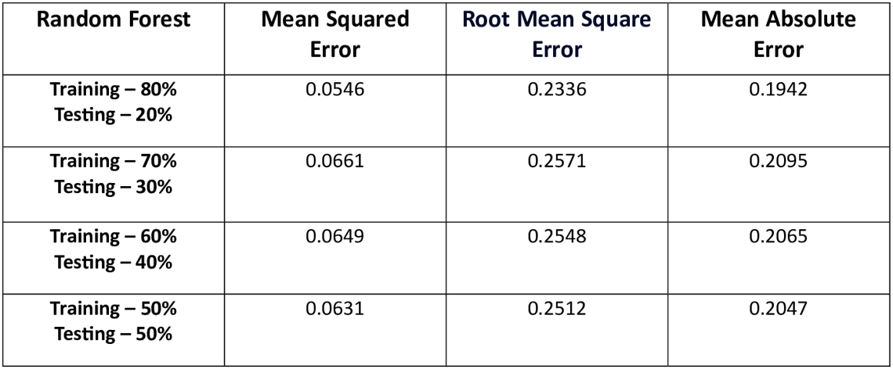 Note: Greater the accuracy more the value tends towards zero.

The table presents the evaluation metrics for a Random Forest model trained on various train-test split ratios of a dataset. The metrics reported are Mean Squared Error (MSE), Root Mean Square Error (RMSE), and Mean Absolute Error (MAE), which are common measures used to assess the predictive performance of regression models. The results reveal that the 80-20 train-test split, where 80% of the data is used for training and 20% for testing, yielded the lowest error values across all three metrics. Specifically, the MSE was 0.0546, the RMSE was 0.2336, and the MAE was 0.1942, indicating relatively low error levels and good predictive accuracy.

As the train-test split ratio was varied, with smaller training set sizes (70%, 60%, and 50%), the error metrics showed a slight increase. For instance, the 70-30 split had an MSE of 0.0661, RMSE of 0.2571, and MAE of 0.2095, while the 50-50 split had the highest errors with an MSE of 0.0631, RMSE of 0.2512, and MAE of 0.2047. This trend is expected, as smaller training set sizes generally lead to lower model performance due to limited data available for learning the underlying patterns.

Overall, the results suggest that the 80-20 train-test split provides the optimal balance between model performance and data utilization for this particular Random Forest model and dataset. However, it is important to consider other factors such as computational resources, data characteristics, and problem-specific requirements when selecting the appropriate train-test split ratio for model training and evaluation.

**5.6. DISCUSSION ON RESULTS:**

The evaluation process yielded insightful results that shed light on the performance and efficacy of the Cyclone Casualty and Property Loss Prediction model, revealing both its strengths and areas for potential enhancement.

The key findings from the assessment of the various models are as follows:

**For Random Forest:**

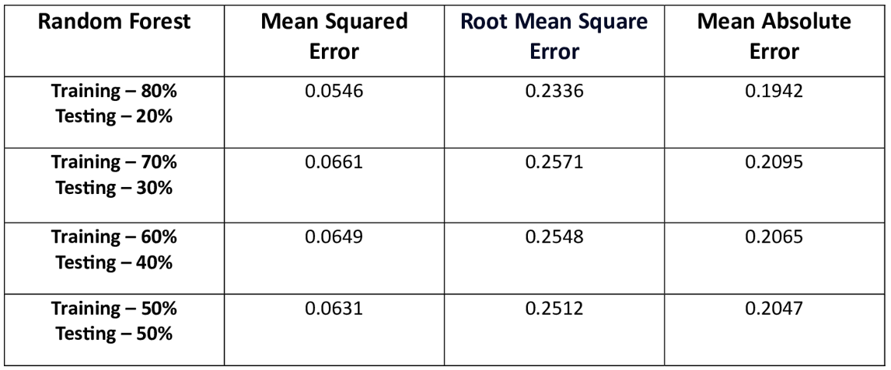

Note: Greater the accuracy more the value tends towards zero.

**For Linear Regression:**

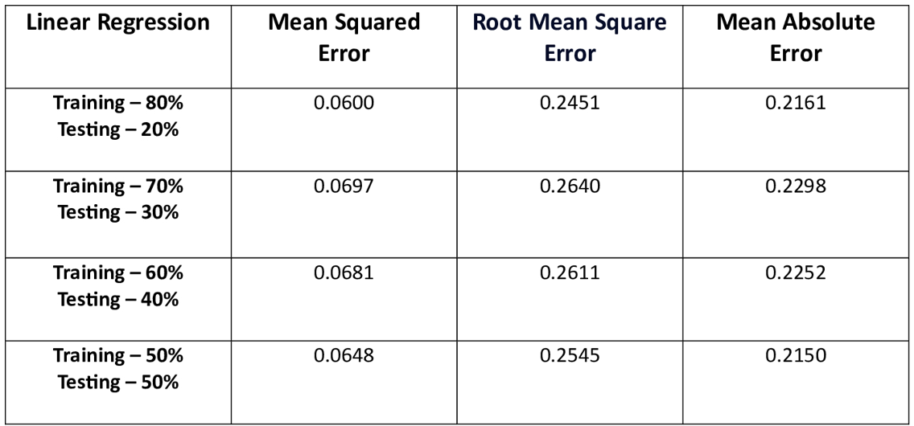 Note: Greater the accuracy more the value tends towards zero.

The evaluation results across various train-test split ratios provide valuable insights into the comparative performance of the Linear Regression and Random Forest models for the Cyclone Casualty and Property Loss Prediction task. Across all split ratios, including the commonly adopted 80-20 split, the Random Forest model consistently outperforms the Linear Regression model in terms of multiple error metrics, such as Mean Squared Error (MSE), Root Mean Square Error (RMSE), and Mean Absolute Error (MAE).

Notably, for the 80-20 split, the Random Forest model exhibits lower error values, with an MSE of 0.0546, RMSE of 0.2336, and MAE of 0.1942, compared to the Linear Regression model's MSE of 0.0600, RMSE of 0.2451, and MAE of 0.2161. This trend holds true across the other split ratios as well, with the Random Forest model maintaining a clear advantage in terms of predictive accuracy.

Furthermore, as the size of the training set decreases, both models experience an expected increase in error metrics due to limited data availability for learning the underlying patterns. However, the Random Forest model consistently exhibits lower error values, indicating its superior ability to capture complex non-linear relationships in the data.

The Mean Absolute Error (MAE) values further reinforce the Random Forest model's advantage, with its MAE ranging from 0.1942 to 0.2095, while the Linear Regression model's MAE ranges from 0.2150 to 0.2298, highlighting the Random Forest model's greater precision in predicting casualties and property losses.

Based on these comprehensive evaluation results, the Random Forest algorithm emerges as the more suitable choice for the Cyclone Casualty and Property Loss Prediction task. Its ensemble nature and capability to model non-linear relationships make it better equipped to handle the complexities inherent in cyclone data, leading to more accurate predictions and ultimately contributing to more informed decision-making in disaster management and mitigation efforts

**Chapter 6: Conclusion and Future Work**

**_____________________________________________________________________________________**

**6.1. Conclusion:**

In conclusion, the development of a Cyclone Casualty and Property Loss Prediction model for India represents a significant step towards enhancing disaster preparedness and response strategies. By integrating diverse datasets, leveraging machine learning algorithms, and designing a user-friendly interface, this project offers valuable insights into the potential impact of cyclones on human lives and property.

Through rigorous analysis and experimentation, the Random Forest model emerged as the most accurate predictor of cyclone casualties and property losses. Key features such as wind speed, population demographics, GDP, and geographic parameters were identified as significant predictors, providing valuable information for decision-makers and stakeholders.

The creation of a python-based Graphical User Interface (GUI) connected to a MongoDB database facilitates seamless interaction with the prediction model, empowering users to input relevant parameters and visualize predicted outcomes in an intuitive manner.

As the frequency and intensity of cyclone events continue to rise due to climate change, the importance of such predictive models becomes even more pronounced. By leveraging cutting-edge technology and interdisciplinary collaborations, this project has the potential to make significant strides in disaster risk reduction, fostering resilient communities and safeguarding lives and livelihoods.

Ultimately, the successful implementation of this cyclone casualty and property loss prediction model can serve as a catalyst for enhanced disaster preparedness, expedited response efforts, and informed policymaking, contributing to a more sustainable and resilient future in the face of these natural hazards.

**6.2. Future Work:**

While this project lays a strong foundation for cyclone prediction and mitigation efforts, several avenues for future work exist:

**Refinement of Predictive Models:** Continuous refinement and optimization of machine learning models can further enhance prediction accuracy and robustness. Exploring advanced techniques such as ensemble methods and deep learning architectures may yield improved results.

**Integration of Additional Data Sources:** Incorporating additional data sources, such as satellite imagery, climate data, and infrastructure information, can enrich the predictive capabilities of the model and provide deeper insights into cyclone impact.

**Enhancement of User Interface:** Iterative refinement of the Graphical User Interface (GUI) based on user feedback and usability testing can improve user experience and accessibility, ensuring broader adoption and utility.

**Real-time Data Integration:** Developing mechanisms for real-time data ingestion and analysis enables timely response and adaptation to evolving cyclone events. Integration with meteorological APIs and IoT sensors can provide up-to-date information for more accurate predictions.

**Community Engagement and Collaboration**: Collaborating with relevant stakeholders, including government agencies, non-profit organizations, and local communities, fosters knowledge sharing, data exchange, and collective action towards cyclone resilience and mitigation.

By pursuing these avenues for future work, researchers and practitioners can further advance cyclone prediction and mitigation efforts, ultimately contributing to the safety and well-being of communities vulnerable to cyclonic disturbances in India and beyond.

**Reference**

**_____________________________________________________________________________________**

[1] Shuxian Liu &Yang Liu (Aug 2023), Evaluation of Tropical Cyclone Disaster Loss Using Machine Learning Algorithms with an eXplainable Artificial Intelligence Approach, (mdpi, 15,12261)

[2] Lin Yang & Chunrong Cao (Dec 2018), Study on Typhoon Disaster Loss and Risk Prediction and Benefit Assessment of Disaster Prevention and Mitigation(Science Direct, Volume 7, Issue 4)

[3] Ji-Myong Kim & Junseo Bae(Aug 2023), A study of deep learning algorithm usage in predicting building loss ratio due to typhoons: the case of southern part of the Korean Peninsula,( Frontiers, Volume 11)

[4] Muhammad Al-Amin Hoquea & Stuart Phinn (2018), Modelling tropical cyclone risks for present and future climatechange scenarios using geospatial techniques, (INTERNATIONAL JOURNAL OF DIGITAL EARTH, 2018VOL. 11, NO. 3, 246–263)

[5] Chen lei, Haiming Xu & Hui Yu (2010),Temporal and Spatial Evolution of precipitation structure before and after Typhoon Sangmei (0608) landfall.(Atmospheric Science, 34 (1) pp. 105-119)

[6] Hen Xiang,& Jing Chen (2007),Preliminary estimation of Typhoon disaster risk Distribution in Fujian Province.(Journal of Natural disasters, 16 (3) pp. 19-22)

[7] Li Y, Zhao S &WangG. (2021) Spatiotemporal variations in meteorological disasters and vulnerability in China during 2001–2020. Front. (Earth Sci. 9, 789523)

[8] Ahmed, B., R. Ahmed, and X. Zhu.(2013).“Evaluation of Model Validation Techniques in Land Cover Dynamics.”(ISPRS International Journal of Geo-Information2 (3): 577–597)

[9] Ahmed, B., I. Kelman, H. K. Fehr, and M. Saha.(2016).“Community Resilience to Cyclone Disasters in Coastal Bangladesh.(”Sustainability8 (8): 805)

[10] Condon, A., and Y. Peter Sheng.(2012).“Evaluation of Coastal Inundation Hazard for Present and Future Climates.”(Natural Hazards62 (2): 345–373)

[11] Shultz, J. M., J. Russell, and Z. Espinel.(2005).“Epidemiology of Tropical Cyclones: The Dynamics of Disaster, Disease,and Development.”(Epidemiologic Reviews27 (1): 21–35)

[12] Weinkle, J., R. Maue, and R. Pielke Jr.(2012.)“Historical Global Tropical Cyclone Landfalls.”(Journal of Climate25 (13):4729–4735.)

[13] Shim, J. S., Kim, J.,and Park, S. J. (2013). Storm surge inundation simulations comparing three-dimensional with two-dimensional models based on Typhoon Maemi over Masan Bay of South Korea. J. Coast. (Res. 65 (65), 392–397.)

[14] Mallick, F., and A. Rahman(.2013.)“Cyclone and Tornado Risk and Reduction Approaches in Bangladesh.”InDisasterRisk Reduction Approaches in Bangladesh, edited by R. Shaw, F. Mallick, and A. Islam, (91–102. Tokyo: Springer)

[15] Depressions of North Indian Ocean.”InMonitoring and Prediction of Tropical Cyclones in the Indian Oceanand Climate Change, edited by U. Mohanty, M. Mohapatra, O. Singh, B. Bandyopadhyay, and L. Rathore, (33–39. New Delhi: Springer.)

[16] Lee, H. S.(2013.)“Estimation of Extreme sea Levels Along the Bangladesh Coast due to Storm Surge and sea Level RiseUsing EEMD and EVA.”(Journal of Geophysical Research: Oceans118 (9): 4273–4285)

[17] Shane Crawford, P., Hainen, A. M., Graettinger, A. J., van de Lindt, J. W., and Powell, L. (2020). Discrete-outcome analysis of tornado damage following the 2011 Tuscaloosa, Alabama, tornado. (Nat. Hazards Rev. 21 (4), 04020040.)

[18] Ulbrich, U., Fink, A. H., Klawa, M., and Pinto, J. G. (2001). Three extreme storms over Europe in december 1999. (Weather 56 (3), 70–80. doi:10.1002)